Blades
- Our Recommended Templates
- Trust Signals
- Create a Teaching Resume in 5 Simple Steps
- Get Expert Writing Recommendations for Your Teaching Resume
- 8 Dos and Don’ts for Writing a Teaching Resume
- Consider These Skills for Your Teaching Resume
- Teaching Resumes for Every Professional Level
- Recommended Teaching Cover Letter
- TrustPilot
- Statistics and Facts About Teaching Jobs

Page title:

Teaching Resume Templates

Page subtitle:

Writing the perfect resume can be a challenge if you want to get a great job in teaching. Check out these helpful tips and resources for resume templates and step-by-step guidance.

Blade 1
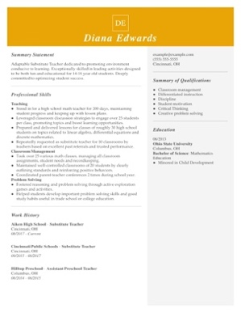
CTA: Customize This Resume

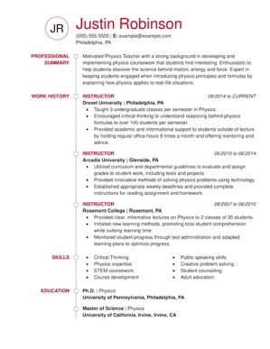
CTA: Customize This Resume
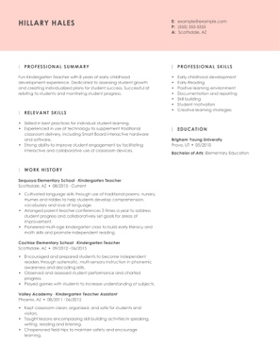
CTA: Customize This Resume
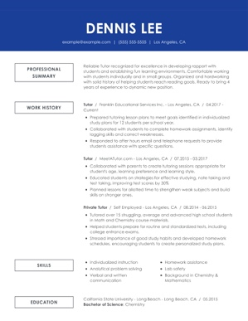
CTA: Customize This Resume
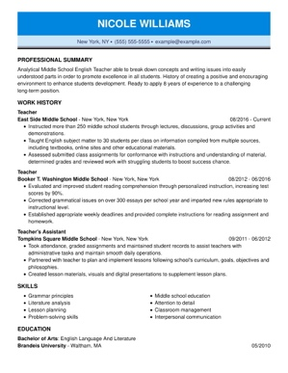
CTA: Customize This Resume

Blade 2

Blade 3

Create a Teaching Resume in 5 Simple Steps

CTA: Build My Resume

Blade 4

Get Expert Writing Recommendations for Your Teaching Resume

The key to a well-written teaching resume is to include industry-specific details that tell a story about your teaching experience. Teaching resumes should convey knowledge of teaching standards, an understanding of child development and behavior, and experience with data-based decisions and academic testing.

LiveCareer’s Resume Builder is a tool that can help you write your teaching resume, fast. Our Resume Builder gives job seekers in the field of teaching suggestions for custom content written by our certified resume writers to help take the guess work out of writing a teaching resume.

Here are some examples of text our builder might recommend for your teaching resume:

- Created daily lesson plans for courses, modifying throughout year to meet time constraints and specific interests of class.
- Met with parents to discuss student behaviors and needs.
- Observed and assessed student performance and charted progress.
- Recorded three lessons on video and audio per week for online instruction.
- Fostered reasoning and problem solving through active exploration games and activities.
- Encouraged critical thinking to understand reasoning behind physics
formulas to over 100 students per semester.

Blade 5

8 Dos and Don'ts for Writing a Teaching Resume

- DO include information about your education. To qualify for most teaching jobs, candidates must have a degree in education from a certified university program. Include your academic credentials in your resume's education section by listing your college degree and major.

- DO list any licenses and awards. Teachers should also list their state licensing information to demonstrate their readiness to lead in a classroom. Be sure to also list any special awards you've won during your career, such as educational grants, school staff awards, National Board Certification awards or anything else noteworthy.

- DO point out technology skills. Today's educators need to be well versed in working with educational technology. Show off your ability to teach with technology, use computers in instruction and lead courses online.

- DO include details about your professional development. Teachers, professors and other education professionals should include relevant training and professional development in their resumes. Certifications and experience in different aspects of education help candidates stand out.

- DON’T forget to write about accomplishments. A stand-out resume differentiates itself with an individual's accomplishments. Give the administrators information about your top achievements, such as improving test scores, reducing behavior referrals, planning field trips and creating amazing media-rich lesson plans for students.

- DON’T forget to add numbers. In the education field, data is increasingly important for measuring student progress. Use the data from your career to your advantage. Back up you achievements with metrics, such the number of points students’ scores improved, percentages of students showing academic excellence and any other quantifiable details.

- DON’T focus on career experiences unrelated to teaching. Part-time jobs, such as retail and restaurant work, aren't usually relevant for a teaching position. If you don't have a lot of teaching experience, point out experiences tutoring, supervising children or working collaboratively with others.

- DON’T make careless mistakes. Attention to detail is important for teachers so be sure to do a thorough edit and complete revision of your resume before sending it off. Teachers are expected to be accurate, so proofread and have someone you trust read over your resume first.

Blade 6

Consider These Skills for Your Teaching Resume

In the education field, the applicant tracking system, or ATS, continues to gain traction with recruiters from schools and districts country-wide. Industry experts predict the demand for ATS services from college and universities will go up at least 3 percent by 2021. This means that your teaching resume must be worded properly to make it through the ATS process.

Recruiters use an ATS to quickly scan resumes for details relevant to open education job positions. LiveCareer's simple Resume Builder helps teaching candidates choose the right words and phrases for this industry to help them pass through the ATS hurdle.

Here are a few of the top recommended hard and soft skill keywords that the ATS might be programmed to scan teaching resumes for:

- Patient and compassionate with students and coworkers
- Organized and efficient with classroom administrative duties
- Skilled collaborator with other teachers
- Experience administering the MAP test
- Ability to create online course content
- Effective classroom management
- Understanding of childhood development
- Experience working with students with special needs
- Knowledge of different learning styles
- Trained in restorative justice practices

CTA: Build My Resume

Blade 7

Teaching Resumes for Every Professional Level

Entry-level Teaching Resume Template: Teaching Assistant

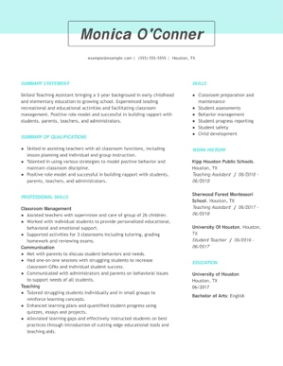

Entry-level teaching candidates face a challenge of presenting their skills with little to no work experience. Candidates with limited experience in a classroom setting should consider a functional resume format, like the example above. This resume format emphasizes education and transferable skills over direct teaching experience.

Even though the candidate has a short history of experience, she provides examples of her ability to manage a classroom, communicate and motivate students. She uses a combination of experiences as a teaching assistant, tutor and teaching intern to show her readiness.

CTA: Build my resume

Mid-career Teaching Resume Template: Associate Professor

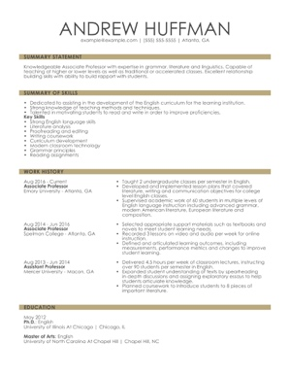

A candidate with several years of teaching experience, such as this associate professor, should consider using a combination resume format to point out his accomplishments and skills, while flaunting a growing work history. This job seeker puts his most impressive education skills at the top of the resume to capture the attention of recruiters.

Then, he details his steady work history in education and includes plenty of information that is specific to teaching at the college level.

The candidate rounds out these strong points but using quantifiable information and outlining his degrees to help him paint a clear picture of his credentials to the recruiter.

CTA: Build my resume

Executive-level Teaching Resume Template: College Professor

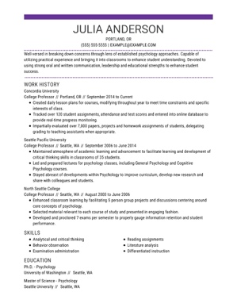

For executive-level candidates, career trajectory is king. This candidate leads with an attention-grabbing summary statement that exudes confidence and ability and her strong work history to make an impression. By using a chronological format she demonstrates her breadth of experience as a college professor and how capable she is to land the open position.

She includes a list of relevant skills lower on the document, while also incorporating teaching skills within the descriptions of her work experience. Finally, her education section lists the necessary qualifications and degrees for a college professor.

CTA: Build my resume

Blade 8

Recommended Teaching Cover Letter
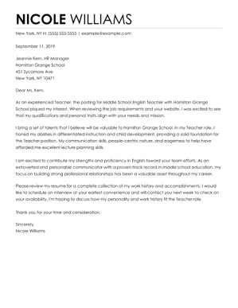

CTA: Build My Cover Letter

Blade 9

TrustPilot

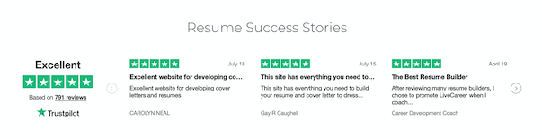

Blade 10

Statistics and Facts About Teaching Jobs

Education Statistics

Private and public school teachers and college education statistics:
*This could be rendered as a chart or graph

- Percentage of teachers with no degree – 2.4%
- Percentage of teachers with a bachelor's degree – 40.5%
- Percentage of teachers with a master's degree – 47.3%
- Percentage of teachers with an advanced education specialist degree – 8.4%
- Percentage of teachers with a doctorate – 1.3%

Source: National Center for Education Statistics

Job Outlook by Job Title 2018-2028

- Preschool teachers – 7% growth
- Elementary school teachers – 3% growth
- Special education teachers – 3% growth
- High school teachers – 4% growth
- Adult education teachers – 5% decline
- Postsecondary teachers – 11% growth
- Teaching assistants – 4% growth

Source: Bureau of Labor Statistics

Demographic Statistics About Public School Teachers

- Gender of elementary school teachers – 89% female/11% male
- Gender of secondary school teachers – 64% female/36% male
- Race and ethnicity data
  - 80% White
  - 7% Black
  - 9% Hispanic
  - 2% Asian
  - 1% Two or more races

Source: National Center for Education Statistics

Public School Teachers and Years of Teaching Experience Distribution Statistics

- Three years of experience or less – 10%
- Between three and nine years of experience – 28%
- Between 10 and 20 years of experience – 39%
- More than 20 years of experience – 22%

Source: National Center for Education Statistics

Number of Postsecondary Full-Time Educators by Job Title

- Professors – 182,924
- Associate Professors – 157,820
- Assistant Professors – 176,347
- Instructors – 100,789
- Lecturers – 42,150
- Other Faculty – 155,730

Source: National Center for Education Statistics

Median Educator Pay by Job Title
*This could be rendered as a chart or graph

- Preschool teachers – $29,780
- Elementary school teachers – $57,980
- Special education teachers – $59,780
- High school teachers – $60,320
- Adult education teachers – $53,630
- Postsecondary teachers – $78,470
- Teaching assistants – $26,970

Source: Bureau of Labor Statistics

Teacher Pay by Location

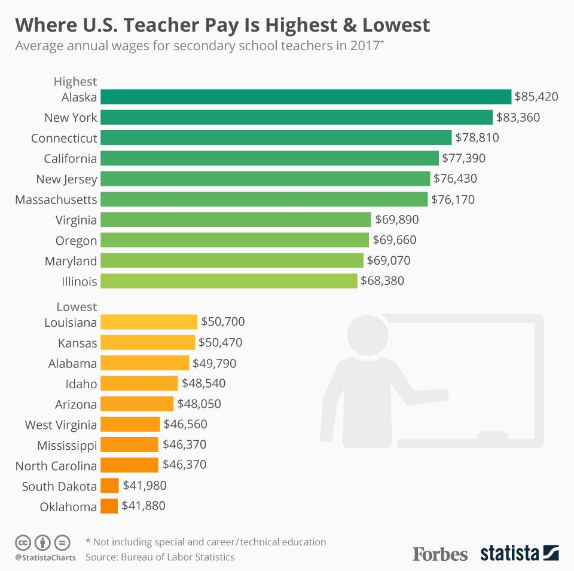

Source: https://www.forbes.com/sites/niallmccarthy/2018/05/09/where-u-s-teacher-pay-is-highest-lowest-infographic/#80eefdb2eab9

College Professor Pay Statistics

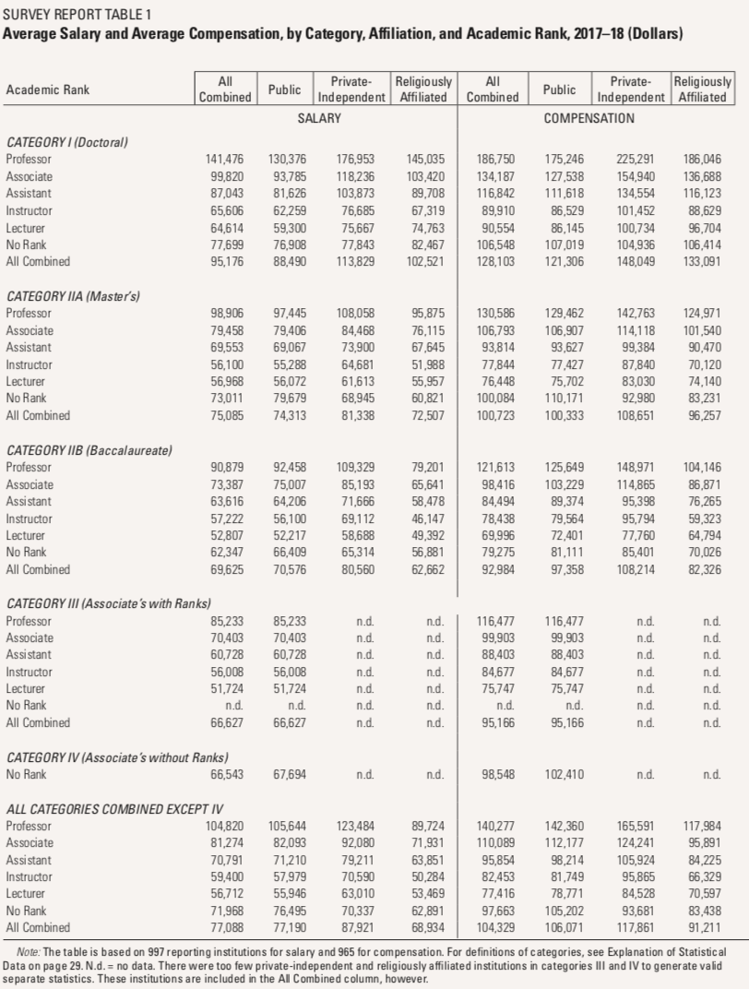

Source: https://www.insidehighered.com/news/2018/04/11/aaups-annual-report-faculty-compensation-takes-salary-compression-and-more

