Blades

- Our Recommended Templates
- Trust Signals
- Create a Retail Resume in 5 Simple Steps
- Get Expert Writing Recommendations for Your Retail Resume
- 6 Dos and Don'ts for Writing a Retail Resume
- Beat the ATS With These Retail Resume Skills
- Retail Resumes for Every Professional Level
- Recommended Retail Cover Letter
- TrustPilot
- Stats and Facts about Retail Jobs

Page title:

Retail Resume Templates

Page subtitle:

Find helpful step-by-step guidance and retail resume templates that make it easy to create a job-winning resume in a few simple steps.

Blade 1: (no copy)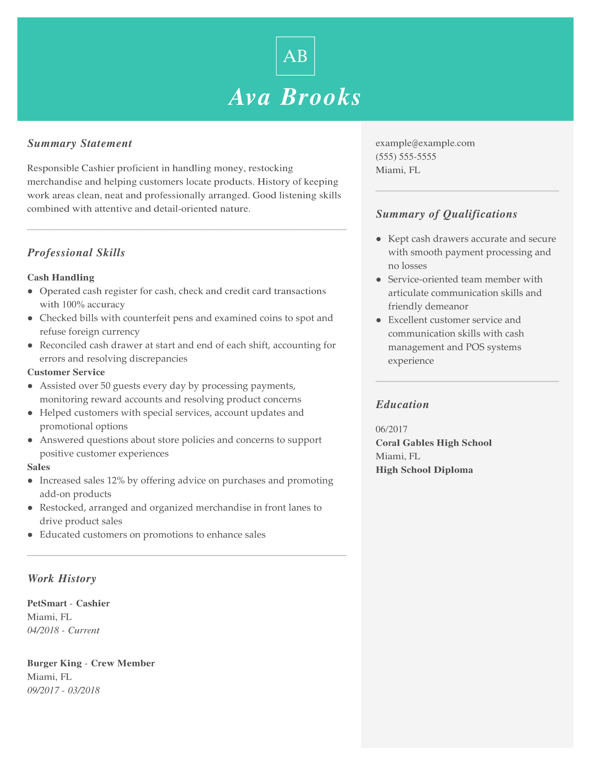

CTA: Customize This Resume

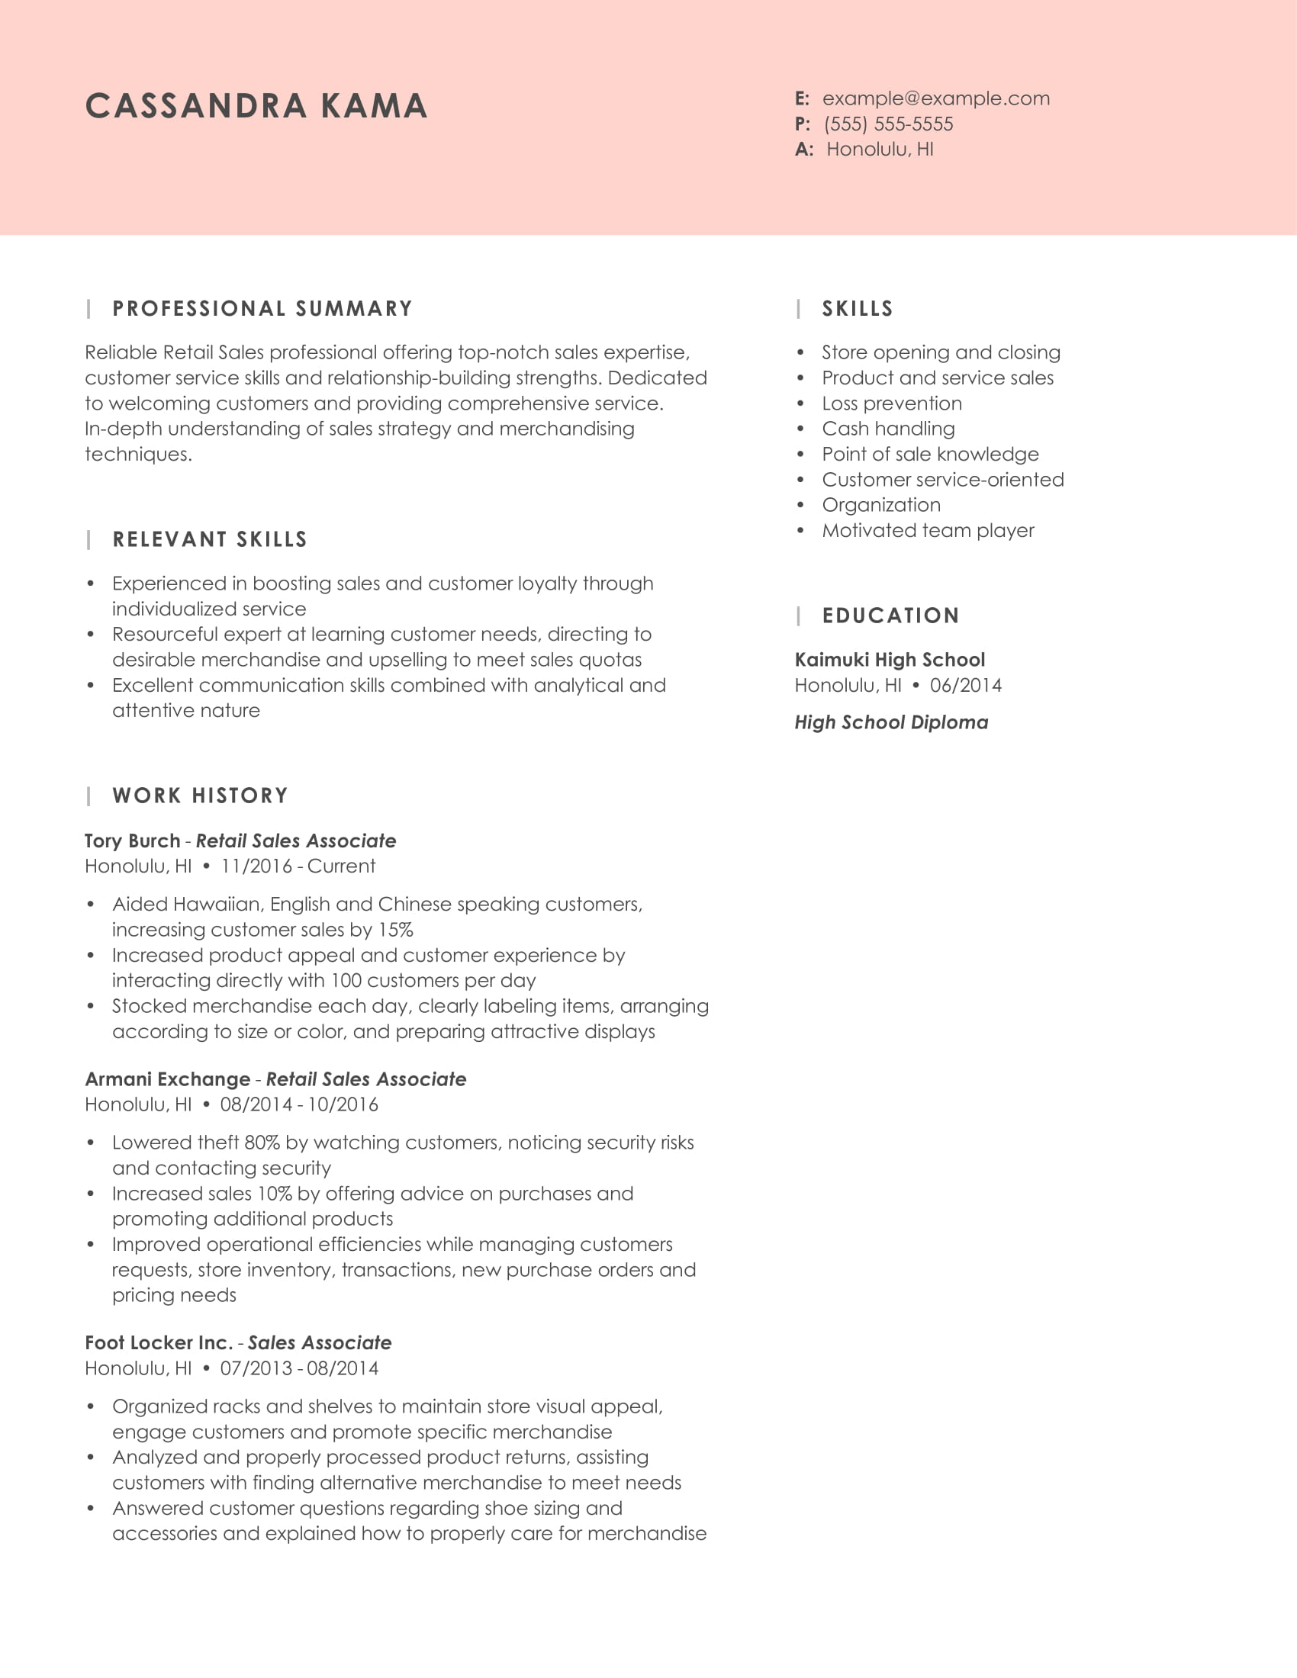
CTA: Customize This Resume

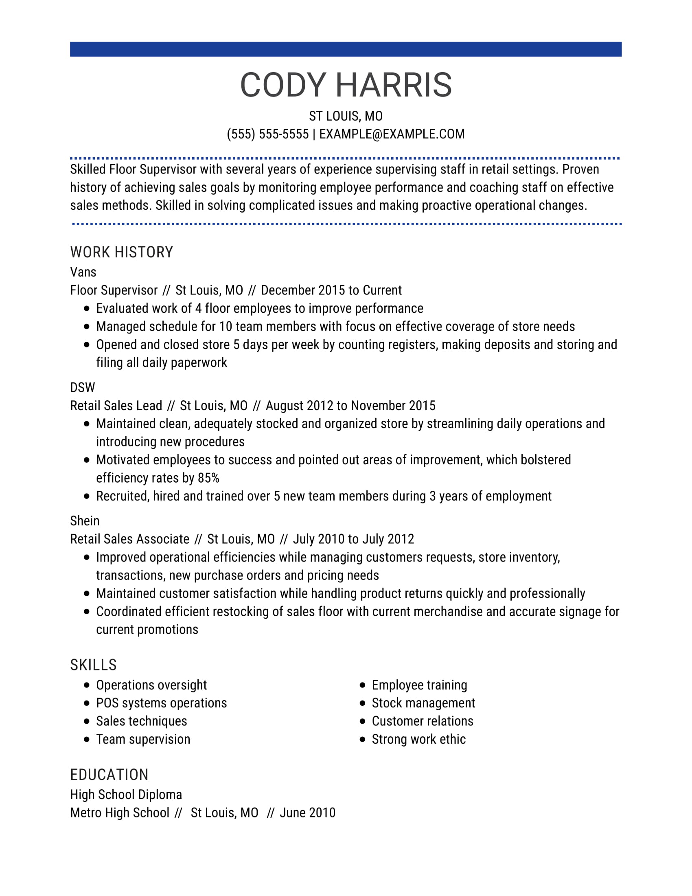
CTA: Customize This Resume

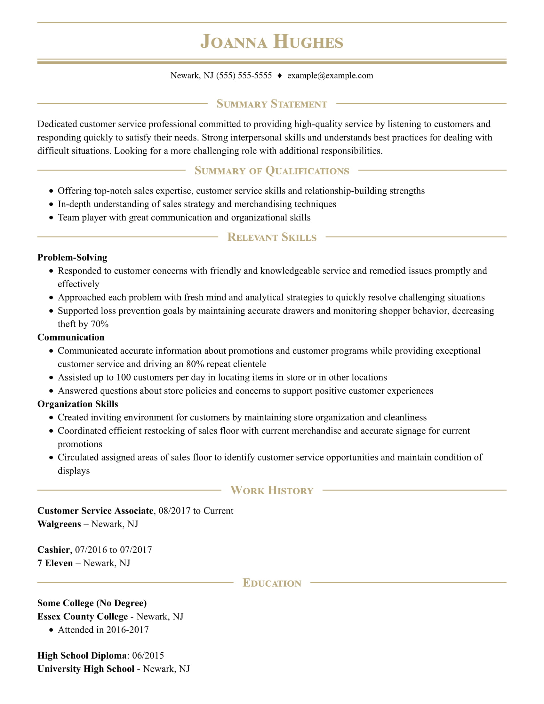
CTA: Customize This Resume

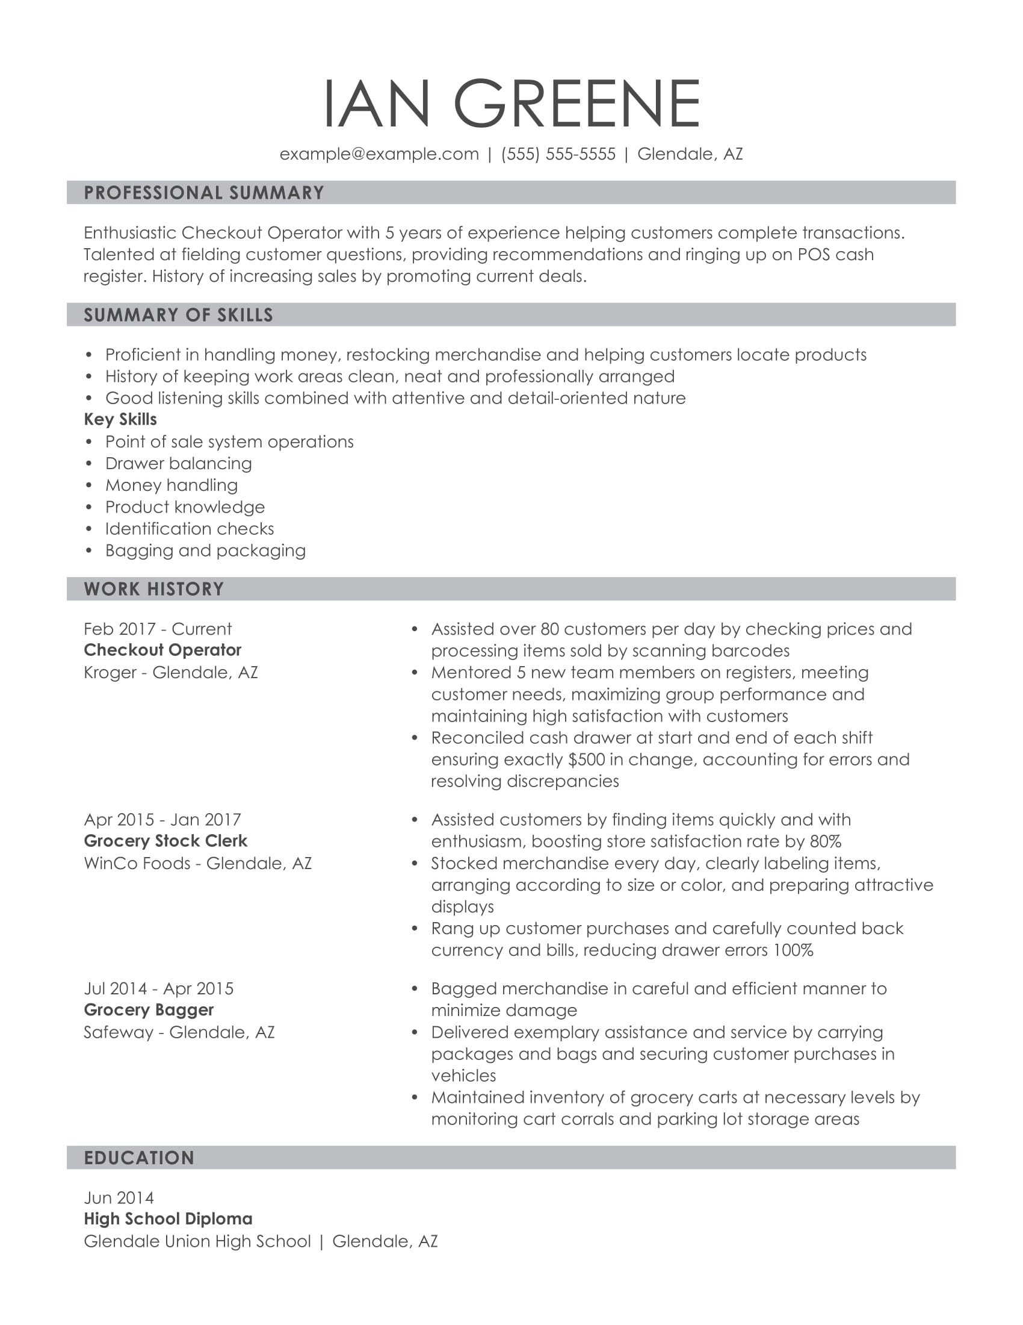
CTA: Customize This Resume

Blade 2: (no copy)

Blade 3: (no copy)

Create a Retail Resume in 5 Simple Steps

CTA: Build My Resume

Blade 4:
Get Expert Writing Recommendations for Your Retail Resume

Our Resume Builder provides retail-specific text suggestions from our certified resume writers. These pre-written text options simplify the writing process, so you can craft a customized retail resume quickly and get the job you want.

The key is being able to show employers which skills and experience you’ll bring to your next retail role. Here are some examples of content our builder might suggest for a retail resume:

- Assessed sales reports to identify and enhance sales performance
- Assisted up to 100 customers per day in locating items in store
- Increased sales 12% by offering advice on purchases
- Stocked merchandise every day, clearly labeling items, and arranging according to size or color
- Increased product appeal and customer experience by interacting directly with customers
- Organized racks and shelves to maintain store’s visual appeal
- Answered customer telephone calls to provide information about store policies
- Processed POS transactions, including checks, cash and credit purchases
- Opened and closed store 5 days per week

Blade 5:

6 Dos and Don'ts for Writing a Retail Resume

As you write your retail resume, follow these expert writing tips:

- DO draw attention to your customer service skills. Detail ways your outgoing and friendly nature make a good impression and help you succeed in resolving customers' complaints.
- DO indicate if you have a flexible schedule. Some retail jobs require nontraditional hours, such as weekend or overnight shifts. A potential employer may prioritize your application if you show that you are willing to work less-desirable shifts.
- DO illustrate your achievements through data and metrics. Don’t just say that you increased revenue by suggesting relevant add-ons in your last role. Use real numbers to quantify your results. For example, mentioning that you were able to upsell customer purchases by an average of 15 percent will pack a punch.
- DO list the languages you speak. Most employers require retail associates to speak fluent English, so it's a good idea to point this out. If you are bilingual or multilingual, include this information on your resume, especially if you are applying to a store where customers likely speak other languages.

- DON'T forget about your physical qualifications. Many retail jobs require extensive walking, lifting and bending. Make sure to include a complete list of these abilities on your resume, especially if the job description mentions them.

- DON'T downplay any relevant experience. Even if your past experience wasn’t in retail, including examples of how you provided exceptional customer service in past roles is valuable. Experience processing customer transactions in a restaurant or efficiently packing bags at a local market shows you have transferable skills.
- DON'T forget to include your relevant education. List the highest level of education you completed. If you have a relevant degree, like a BA in Merchandise Management, be sure to list it. If not, showcase your participation in retail-related activities such as fundraising, ticket sales and event preparation.

- DON'T leave out your achievements. In your work experience section, make sure to point out accomplishments such as Employee of the Month awards, positive customer reviews and record-breaking sales statistics.

Blade 6:

Consider These Skills for Your Retail Resume

Many recruiters nowadays are using computer programs called applicant tracking systems (ATS) to scan submitted resumes to weed out unqualified candidates. ATS software looks for certain phrases and keywords, typically outlined in the job ad, to determine if a candidate has the required qualifications.

When you're applying for a retail position, chances are good that an ATS will read your resume before a human does, especially if you are applying for a job at a large retail store that's part of a national or international brand.

The key to getting your resume past an ATS is using the right language to describe your skills and work experience.

LiveCareer’s Resume Builder makes it easy by suggesting sought-after skills for the retail industry. Here are some suggestions the builder might make for a retail resume:

- Upselling items to customers
- Stocking and restocking shelves
- Mental arithmetic for handling cash transactions
- Arranging holiday and sales displays in stores
- Salesmanship
- POS operation
- Accepting returns and processing refunds
- Answering customer questions and recommending products
- Product knowledge
- Merchandising

CTA: Build My Resume

Blade 7:

Retail Resumes for Every Professional Level

Entry-level Retail Resume Template: Fitting Room Attendant

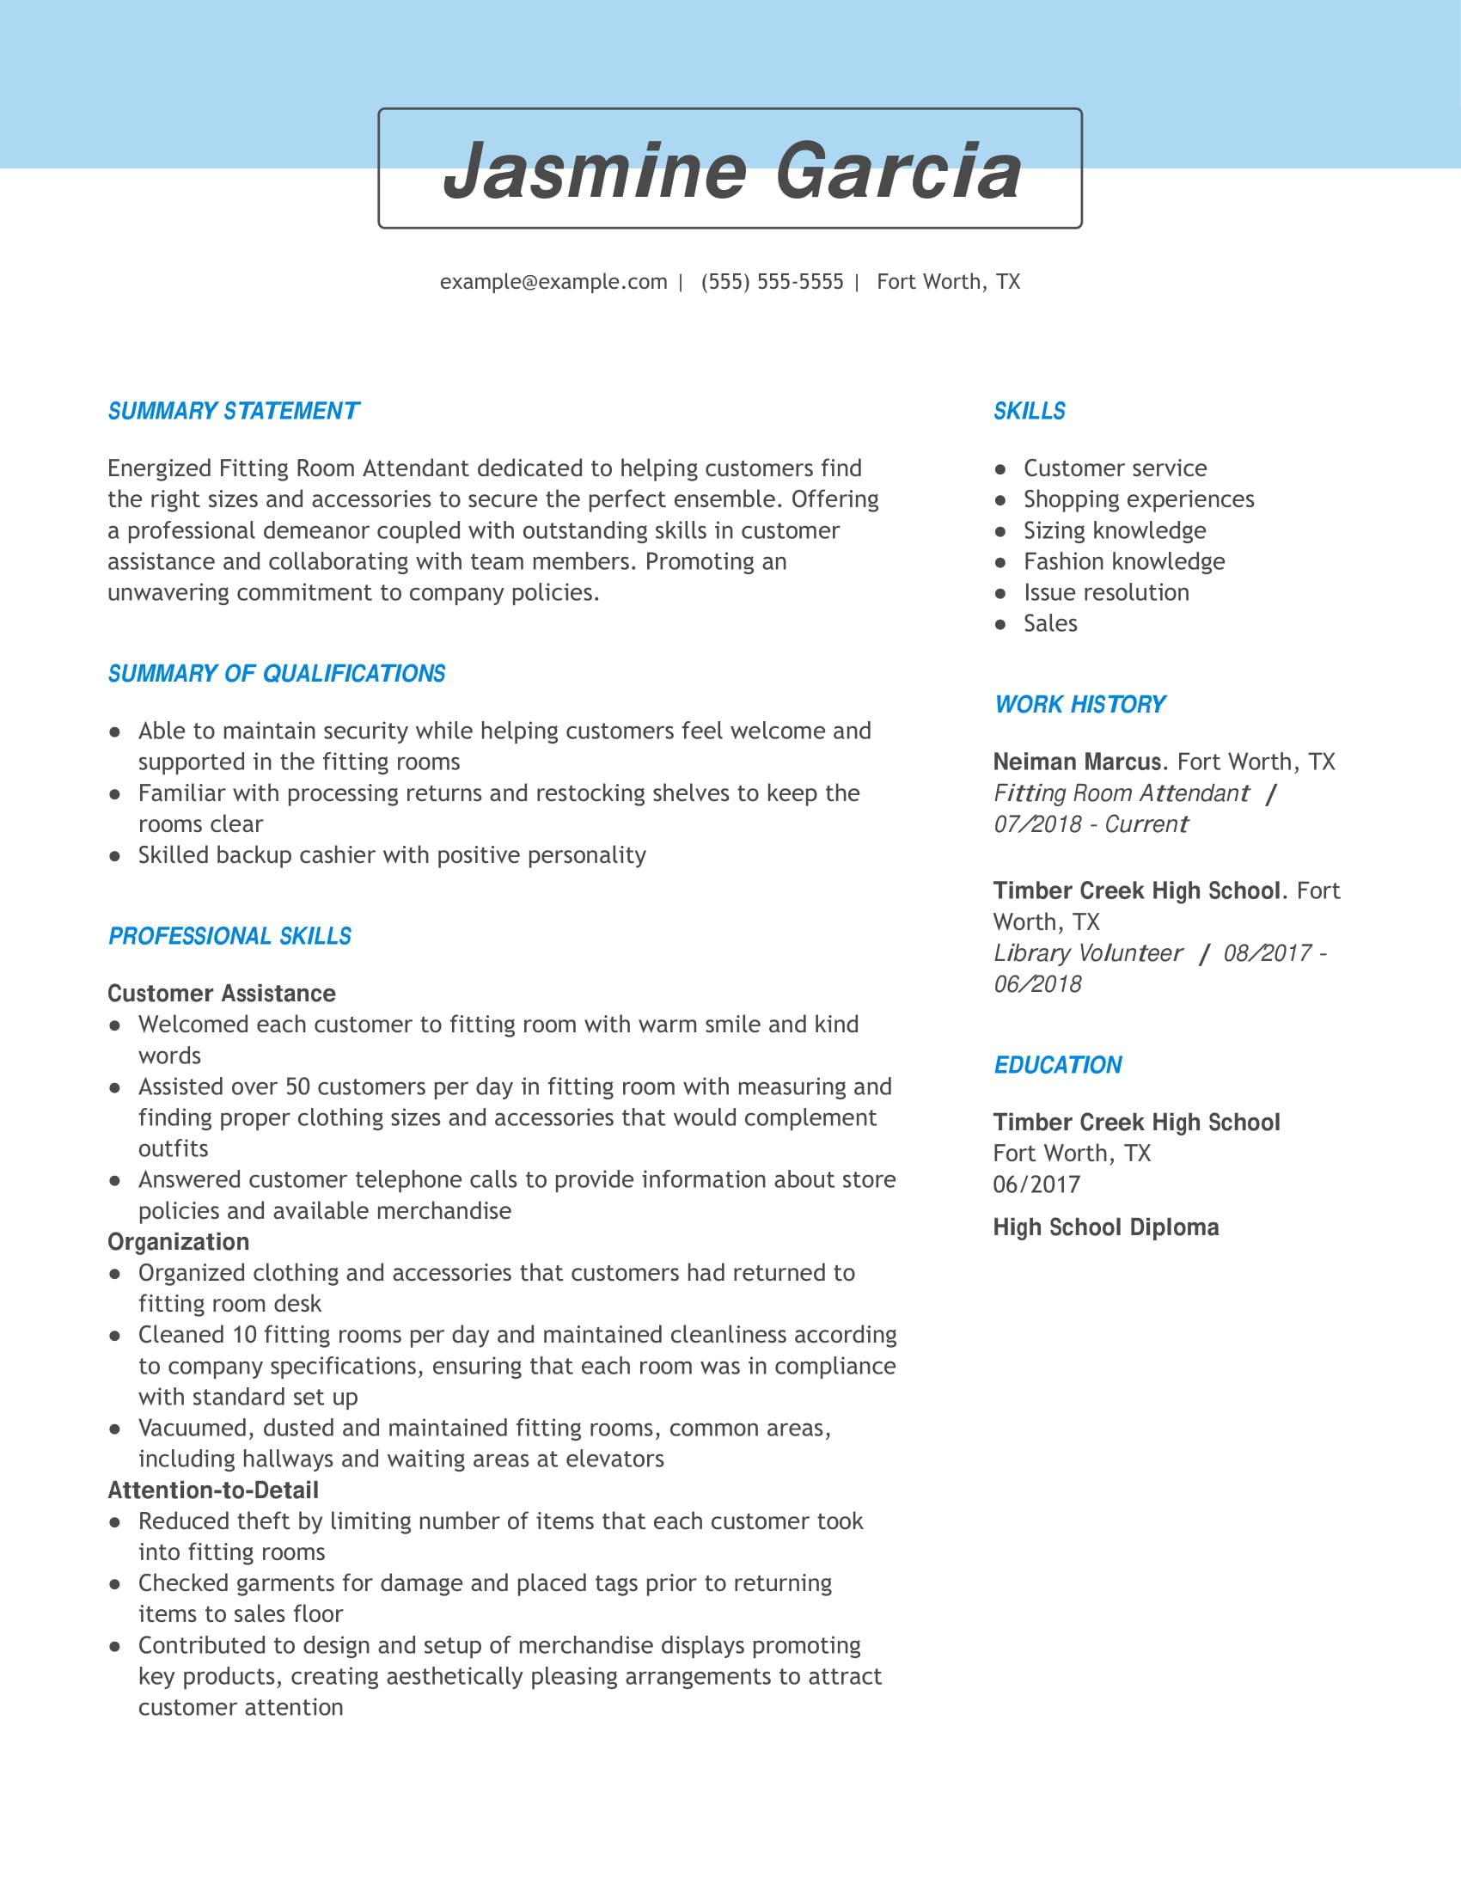
This resume for an entry-level retail position uses a functional resume format to draws attention away from her limited work experience and onto her relevant professional skills, including customer assistance, organization and attention to detail. She also uses the Professional Skills section to convey concrete examples of how she used each skill in action during previous jobs.

Another plus for this candidate is the inclusion of real-world metrics (e.g. 50 customers, 10 fitting rooms) to showcase her contributions to previous employers. To bolster her relatively short career history, she has included her work as a library volunteer since it was a customer-facing role.

CTA: Build my resume

Mid-career Retail Resume Template: Lead Cashier

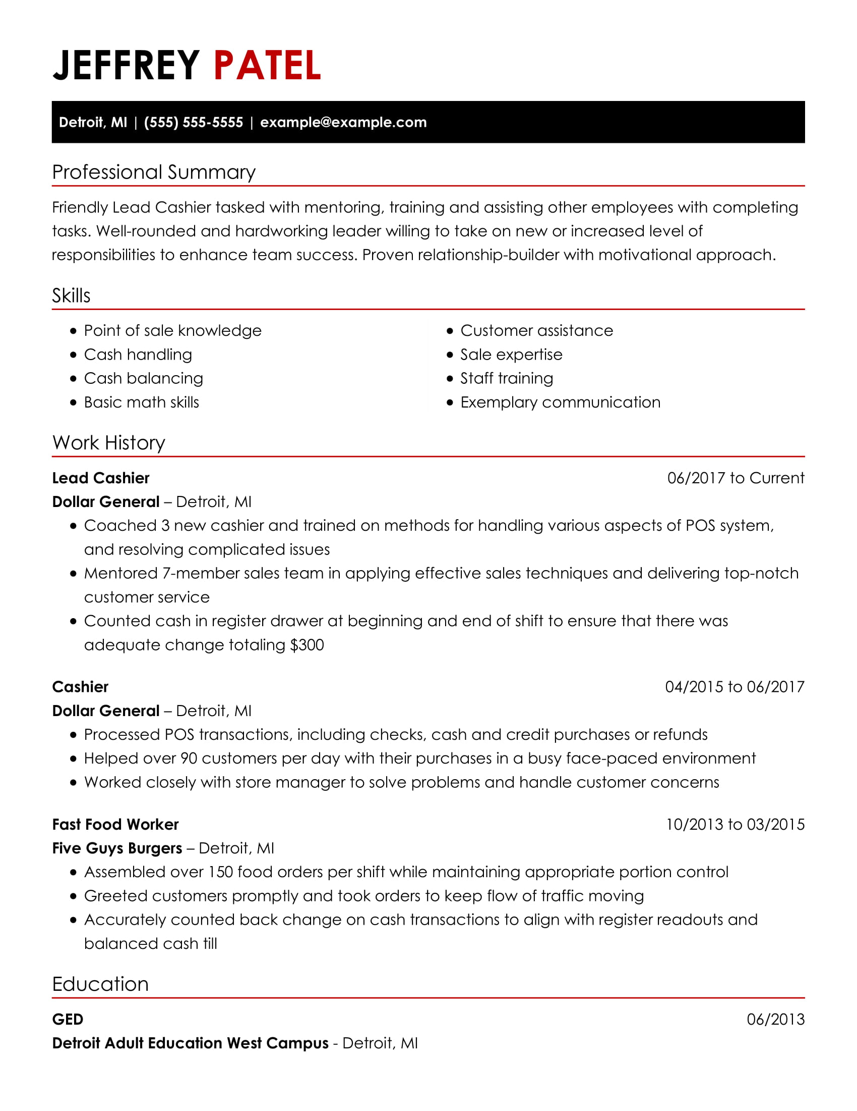
In this mid-level resume, the candidate uses a combination resume format to focus hiring managers immediately on his skills, which include training, friendly, customer assistance, math skills and cash handling. In addition, his work history shows a clear progression in customer service positions, culminating in his current role as a lead cashier. This resume example also includes several impressive metrics, such as handling hundreds of dollars in cash, training several new cashiers, and interacting with nearly 100 customers every day.

CTA: Build my resume

Executive-level Retail Resume Template: Retail Store Manager

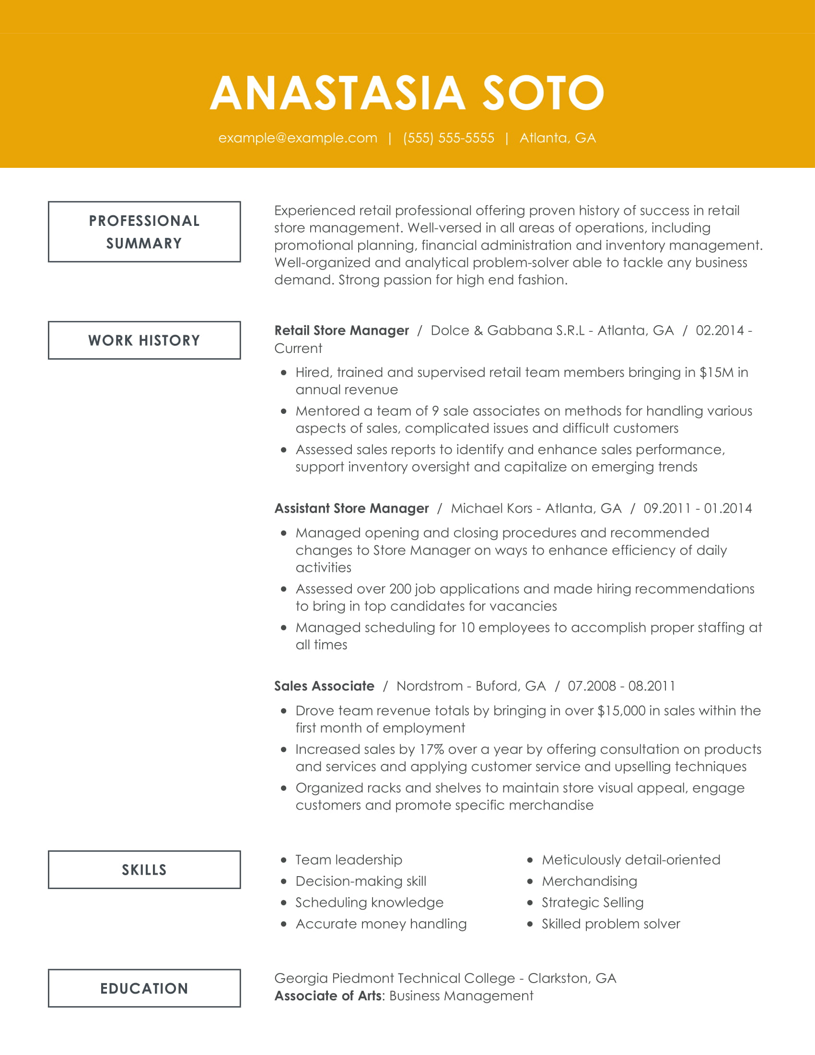

This resume for an executive-level position showcases the candidate's quick advancement through retail jobs by using a chronological resume format. Her impressive career history provides proof of the qualifications stated in the skills section, including team leadership, strategic selling, merchandising and problem-solving. The professional summary also focuses on essential qualities for a retail executive, including experience with inventory management, operations and promotional planning. The candidate clearly indicates her enthusiasm for high-end fashion, which could help her application stand out to hiring managers in luxury boutique establishments.

CTA: Build my resume

Blade 8:

Recommended Retail Cover Letter

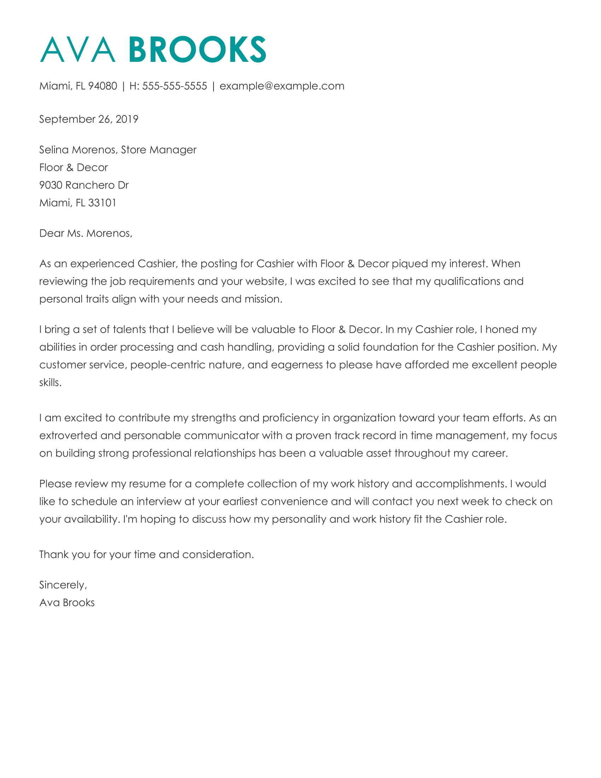
CTA: Build My Cover Letter

Blade 9: TrustPilot [no copy]
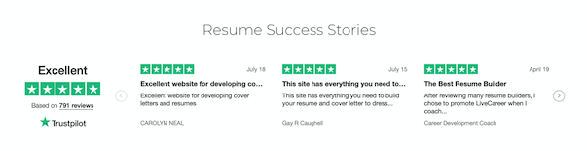

Blade 10:

Statistics and Facts About Retail Jobs

A thorough understanding of the retail industry combined with our easy-to-use resume builder can help you get the job you want. Here are some key points to consider:

1. Training

Most entry-level and mid-level retail sales positions don't require college degrees because employers provide on-the-job training.
Source: Bureau of Labor Statistics

2. Education

If you want to become a sales manager who recruits, trains and supervises teams of retail employees, you may need to earn a bachelor's degree. Some common degree subjects include economics, business law, accounting and marketing.
Source: BLS

3. Median Annual Salary by Experience
(Could be rendered as a chart or graph)

The median annual salary for retail sales employees is $24,200. However, there is a significant jump in pay for workers who move from an entry-level sales role to an oversight position. The average annual salary for first-line supervisors of retail sales workers is $49,978. Moving up from first-line supervisor to sales manager may come with an even larger salary increase; the median pay for sales managers is $124,220.
Source: O*Net, DataUSA, BLS

4. Gender Diversity
(Could be rendered as a chart or graph)

There are more female retail salespeople, with the position averaging 54% female workers to 46% male. However, men in retail sales make on average nearly double what women in these positions do.

Source: DataUSA

5. Most Common Retail Industries

The most common industry for retail jobs is grocery stores, with a workforce of over 1.3 million in the U.S. Department and discount stores are the next most common industry, with over 1 million employees.

Source: DataUSA

6. Retail Job Growth

While statistics indicate the overall number of available retail sales jobs will likely decrease by 2% over the next 10 years, projections show a 3.77% increase in opportunities for first-line supervisors of retail workers over the same time period.
Sources: BLS, DataUSA

7. Changing Landscape

As brick-and-mortar stores attempt to compete with online shopping outlets, some companies are requiring their retail sales workers to take on additional responsibilities, such as supporting drive-up order delivery or home-based shopping.
Source: Associated Press

8. Upward Mobility

While many workers report that retail sales positions can be stressful, they also offer a higher-than-average level of upward mobility, providing numerous opportunities for employees to advance to positions that offer more responsibility and increased pay.
Source: U.S. News and World Report

