LC – P1P
Category Page Assignment Brief

Food Service
Related Tickets: [MOU1]

Blades
- Our Recommended Templates
- Trust Signals
- Create a Food Service Resume in 5 Simple Steps
- Get Expert Writing Recommendations for Your Food Service Resume
- 6 Dos and Don’ts for Writing a Food Service Resume
- Beat the ATS With These Food Service Resume Skills
- Food Service Resumes for Every Professional Level
- Recommended Food Service Cover Letter
- Trustpilot
- Stats and Facts About Food Service Jobs

Page title:
Food Service Resume Templates

Page subtitle:
Find out how our food service resume templates can help you create an exceptional document that will help you get the job you’ve always wanted.

Blade 1: (no copy)
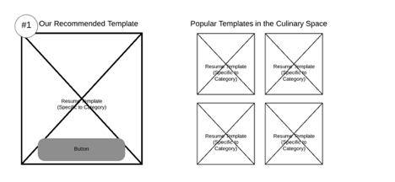

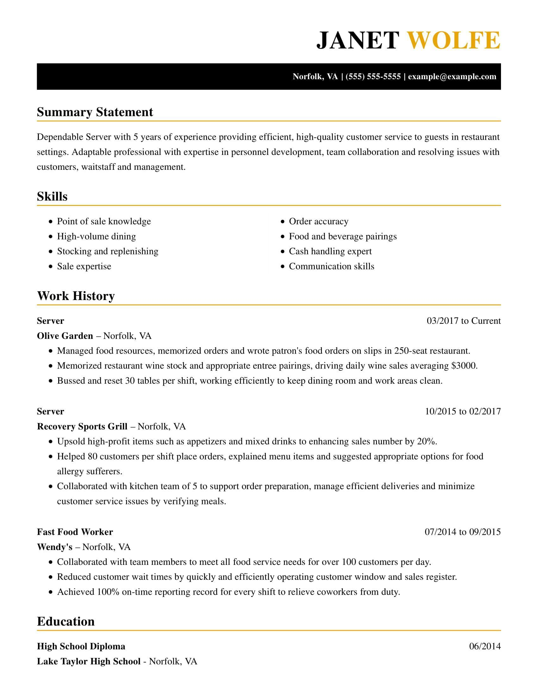
CTA: Customize This Resume
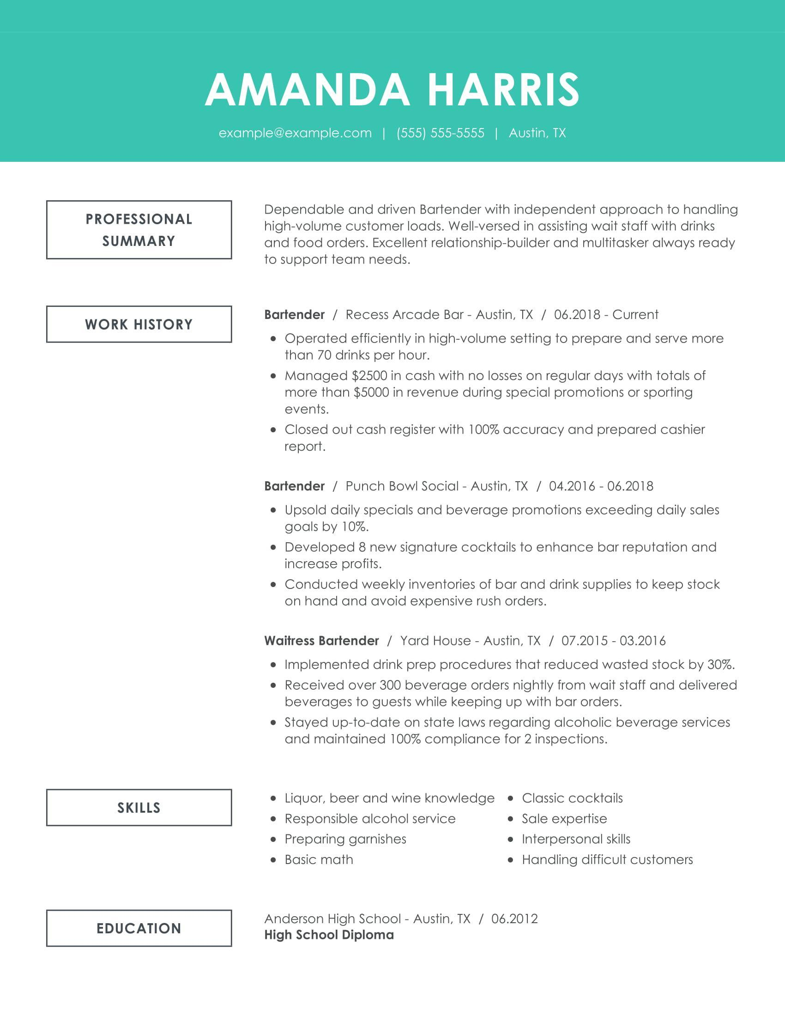
CTA: Customize This Resume

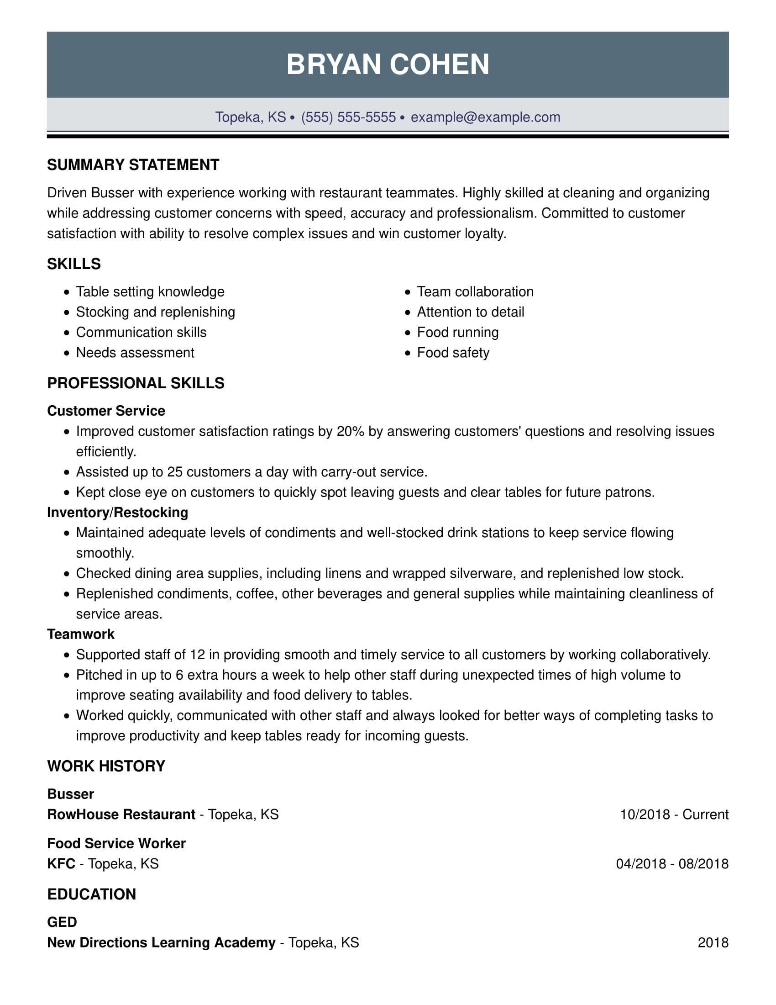

CTA: Customize This Resume

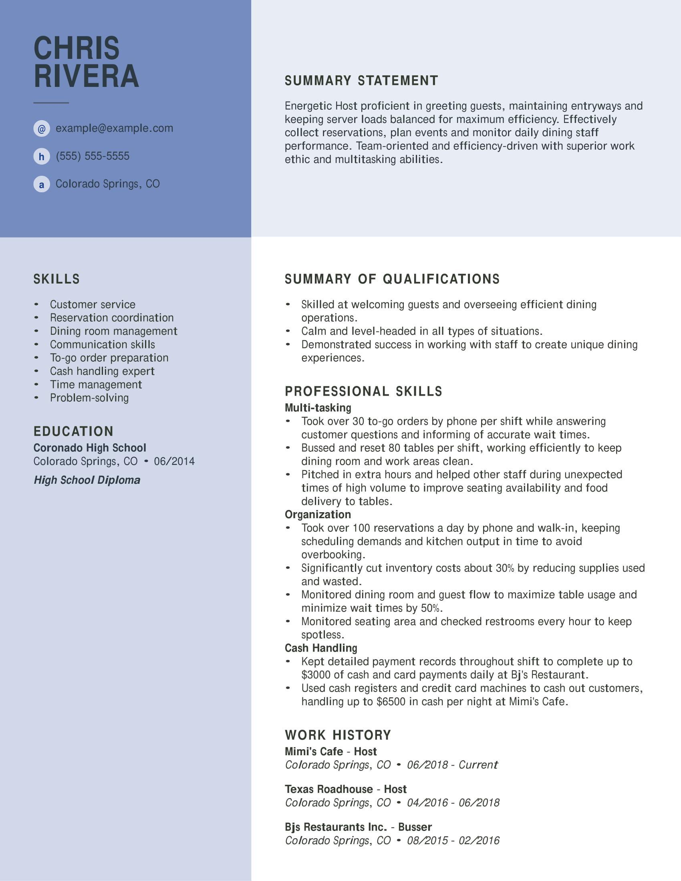
CTA: Customize This Resume
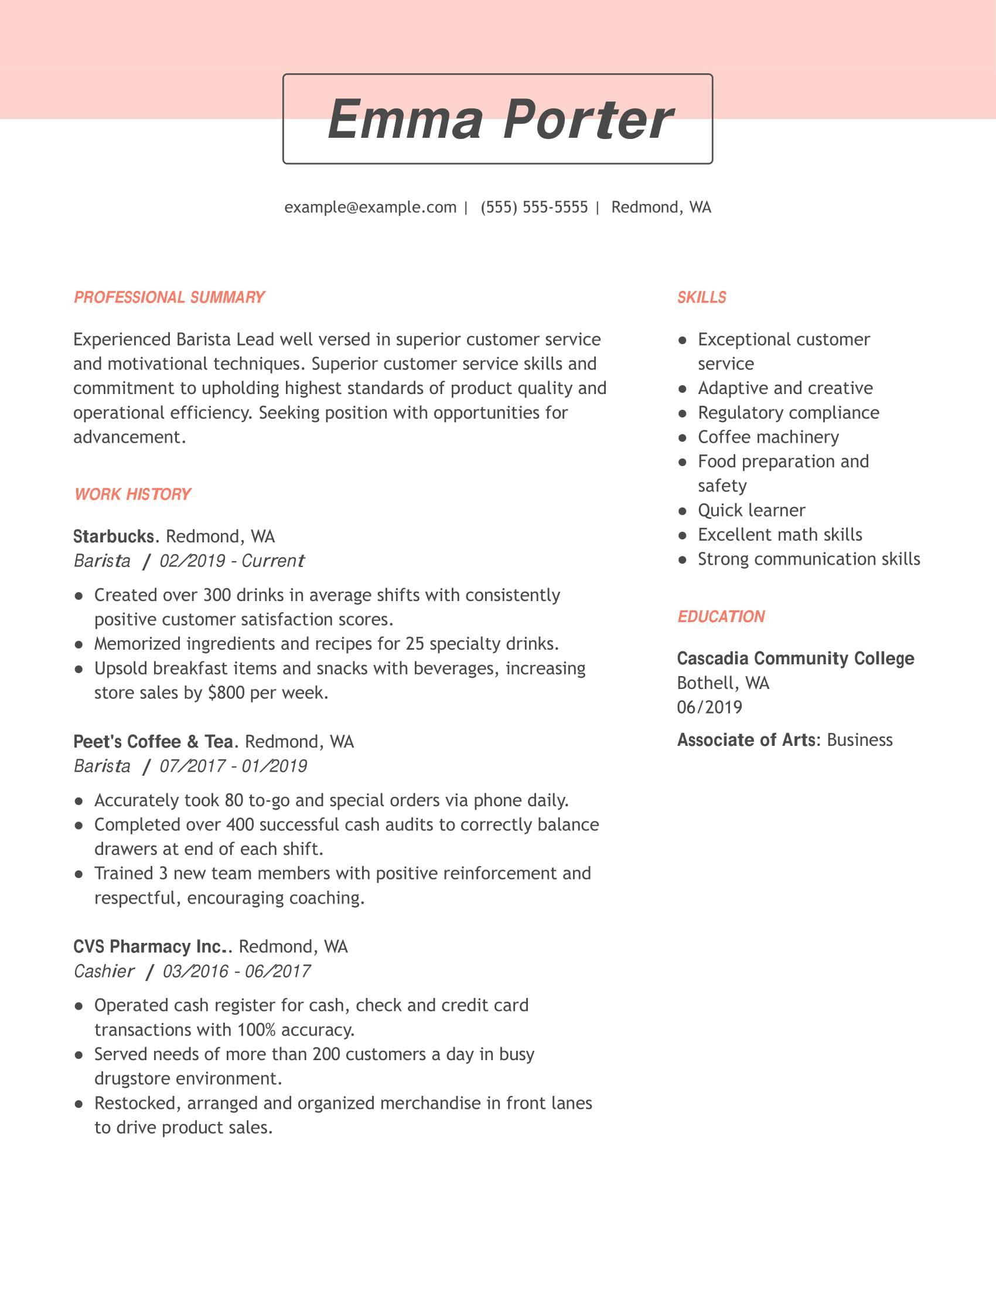

CTA: Customize This Resume

Blade 2: (no copy)

Blade 3: (no copy)

Create a Food Service Resume in 5 Simple Steps

CTA: Build My Resume

Blade 4:
Get Expert Writing Recommendations for Your Food Service Resume
Being able to articulate your skills and experience is critical in the food service industry. Cultivating this skill can turn even the most mundane tasks into extraordinary accomplishments.
LiveCareer’s Resume Builder makes writing a food service resume quick and easy by providing text suggestions for every section.
Here are some examples of text the builder might recommend for the Work History section of your food service resume:
- Memorized restaurant wine stock and appropriate entree pairings, driving daily wine sales.
- Tended bar at special events up to five times a month and directed the team to provide exceptional service for social gatherings.
- Maintained adequate levels of condiments and well-stocked drink stations to keep service flowing smoothly.
- Delivered in-depth training to workers in food preparation and customer-facing roles to promote strong team performance.
- Compiled 25 recipe ingredients and prepared them for cooking by washing, cutting and/or measuring food items.
- Operated efficiently in a high-volume setting to prepare and serve more than 70 drinks per hour.

Blade 5:
8 Dos and Don’ts for Writing a Food Service Resume
Do Choose an Appropriate Food Service Template. Some restaurants are fun and playful while others are more formal and reserved. Your resume templates should reflect the difference. Choose a design that mirrors your personality and the restaurant’s general vibe.
Do Use Active Voice for Descriptions. When job seekers use the active voice, it displays more confidence and shows that you got the job done. Consider the difference between saying you were responsible for memorizing 50 wine and entree pairings versus saying that you accurately memorized all 50.
Do Use Figures When Appropriate. Many people reserve figures for tech, accounting, and other STEM-field resumes. However, using figures can lend further credibility to your resume and experience. Quantify not just the work you did but the advantages this generated for the restaurant or bar. For example, “Upsold dessert items, increasing store sales by $800 per week.”
Do Get Creative: Some food service roles call for creativity and others do not, but the restaurant business overall does. Try to strike a balance between fun and formal by getting creative with descriptions. This can help your resume stand to a hiring manager who is likely reading anywhere from dozens to hundreds of applications.
Don’t Forget to Focus on Food Service: Even if you had a great corporate job in tech before moving into food service, it’s a good idea to keep your resume centered on your direct experience in the field. If you don’t yet have a lot of food service experience, then point out your transferable skills. For example, customer service skills gleaned as a receptionist will come in handy as a server or hostess.
Don’t Forget the Soft Skills: Focusing on your food service skills and qualifications is important. However, employers also appreciate soft skills, such as communication. This skill comes in handy when listening to customers to keep track of complex orders and multiple requests.
Don’t Get Too Wordy: Many people who work in food service are passionate about what they do. Still, it’s important not to get wordy with the descriptions. Focus on writing succinct descriptions of what you did, the effect it had on the establishment and customers, and any numbers you may have to support those results.
Don’t Exaggerate the Truth: An employer with experience in food service can spot an exaggeration or accomplishments that don’t look feasible. He or she may then call your previous employer to verify, could cause you embarrassment. Stick to the truth on your food service resume.

Blade 6:
Beat the ATS With These Food Service Resume Skills
When writing a food service resume, you need to consider how you will get past recruitment software. Known as applicant tracking systems (ATS), these programs scan resumes for preset keywords and then create a shortlist.
LiveCareer’s Resume Builder helps you beat ATS by pinpointing the right skills for food service. Depending on the position you have in mind, these may include any of the following:
- Ability to work in a fast-paced bar or restaurant environment
- Flexible schedule
- Clear tables quickly and efficiently
- Ability to neutralize conflict in a bar setting
- Sanitize utensils after use
- Memorize menus, specials, and wine pairings
- Manage alcohol inventories
- Ability to keep track of customers’ alcohol consumption
- Record orders accurately
- Set tables for up to a 12-course meal

CTA: Build My Resume

Blade 7:
Food Service Resumes for Every Professional Level
Entry-level Food Service Resume Template: Food Service Worker
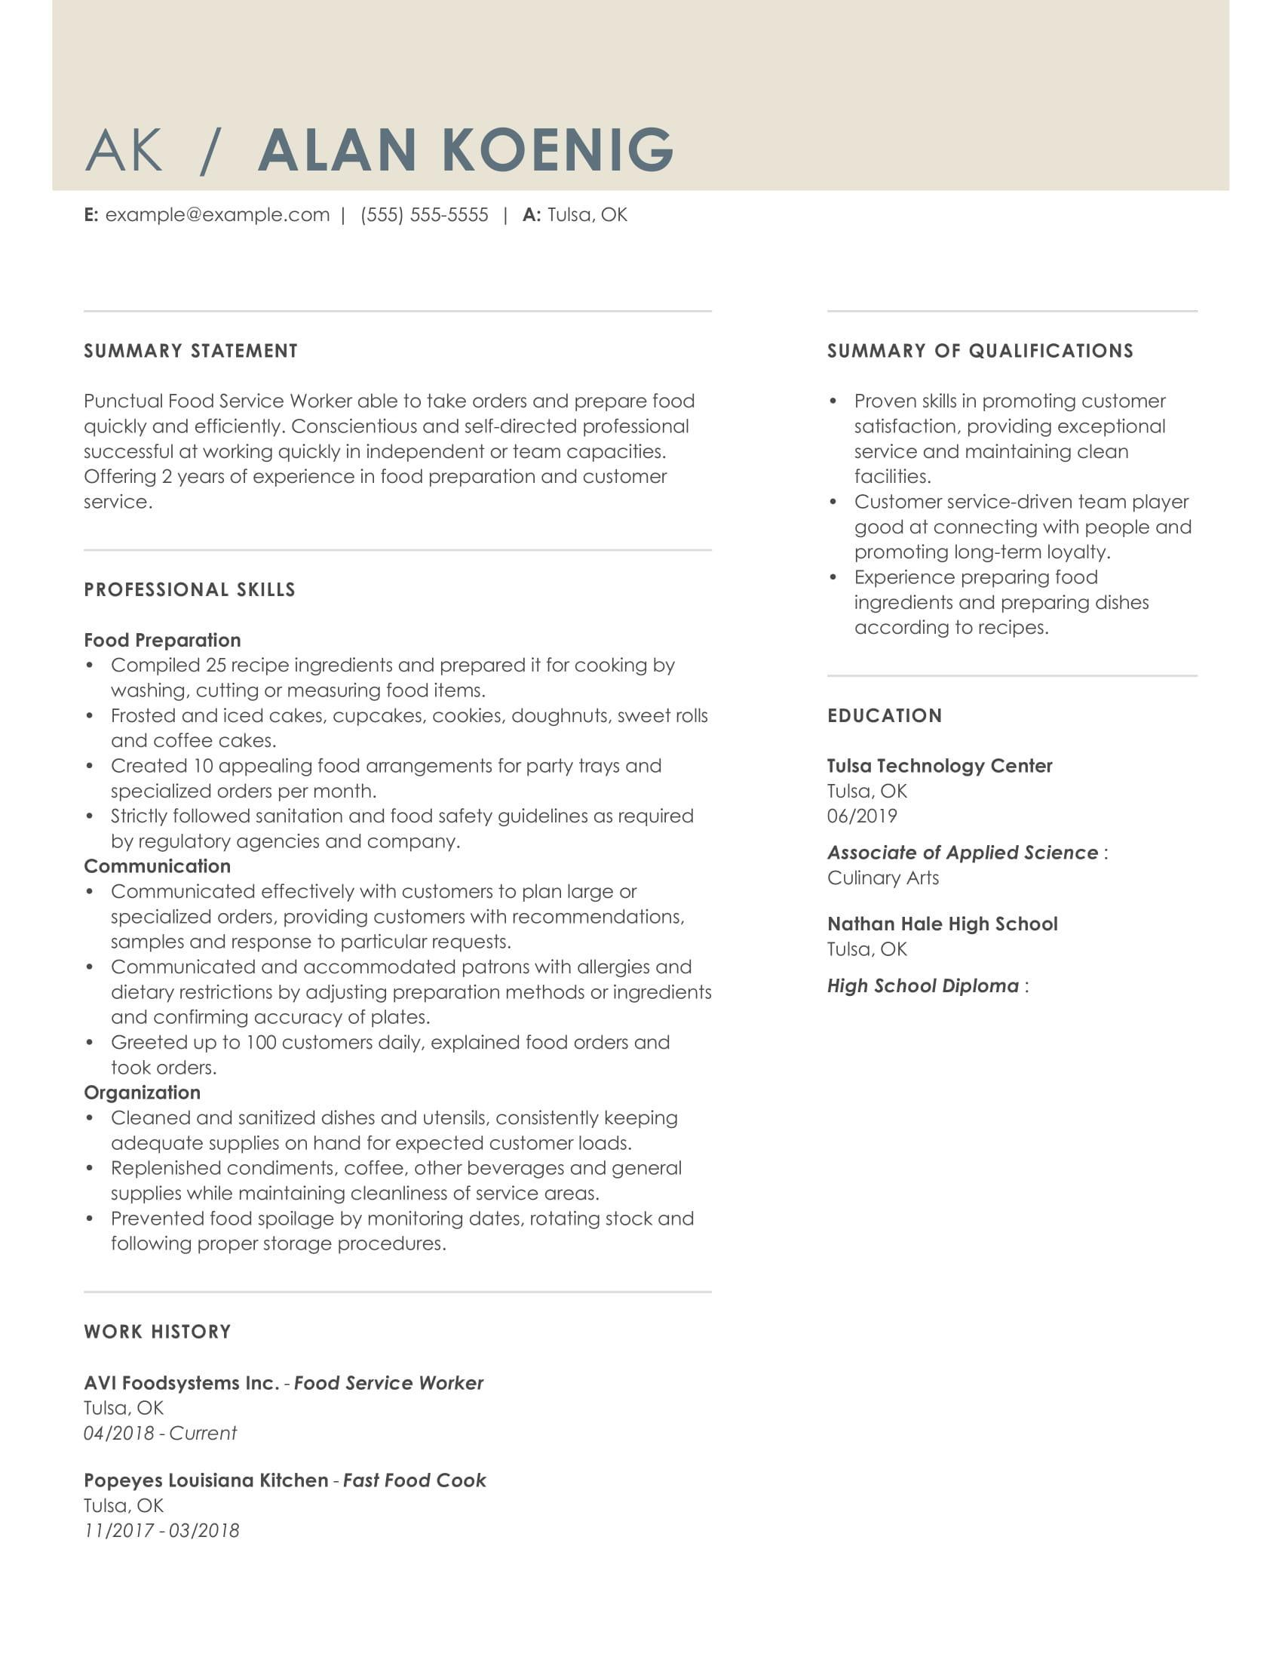
Food service workers with very little experience may still bring other assets to the table. Choosing a template that utilizes a functional format, like the one above, can help them flaunt this by focusing more on professional skills, education and general qualifications than on work experience.
This helps to show employers that while the person has not been working in the business for long, they have invested in in education in Culinary Arts and have acquired that basic skills needed to be successful in a restaurant or bar once hired.
CTA: Build my resume
Mid-career Food Service Resume Template: Head Bartender
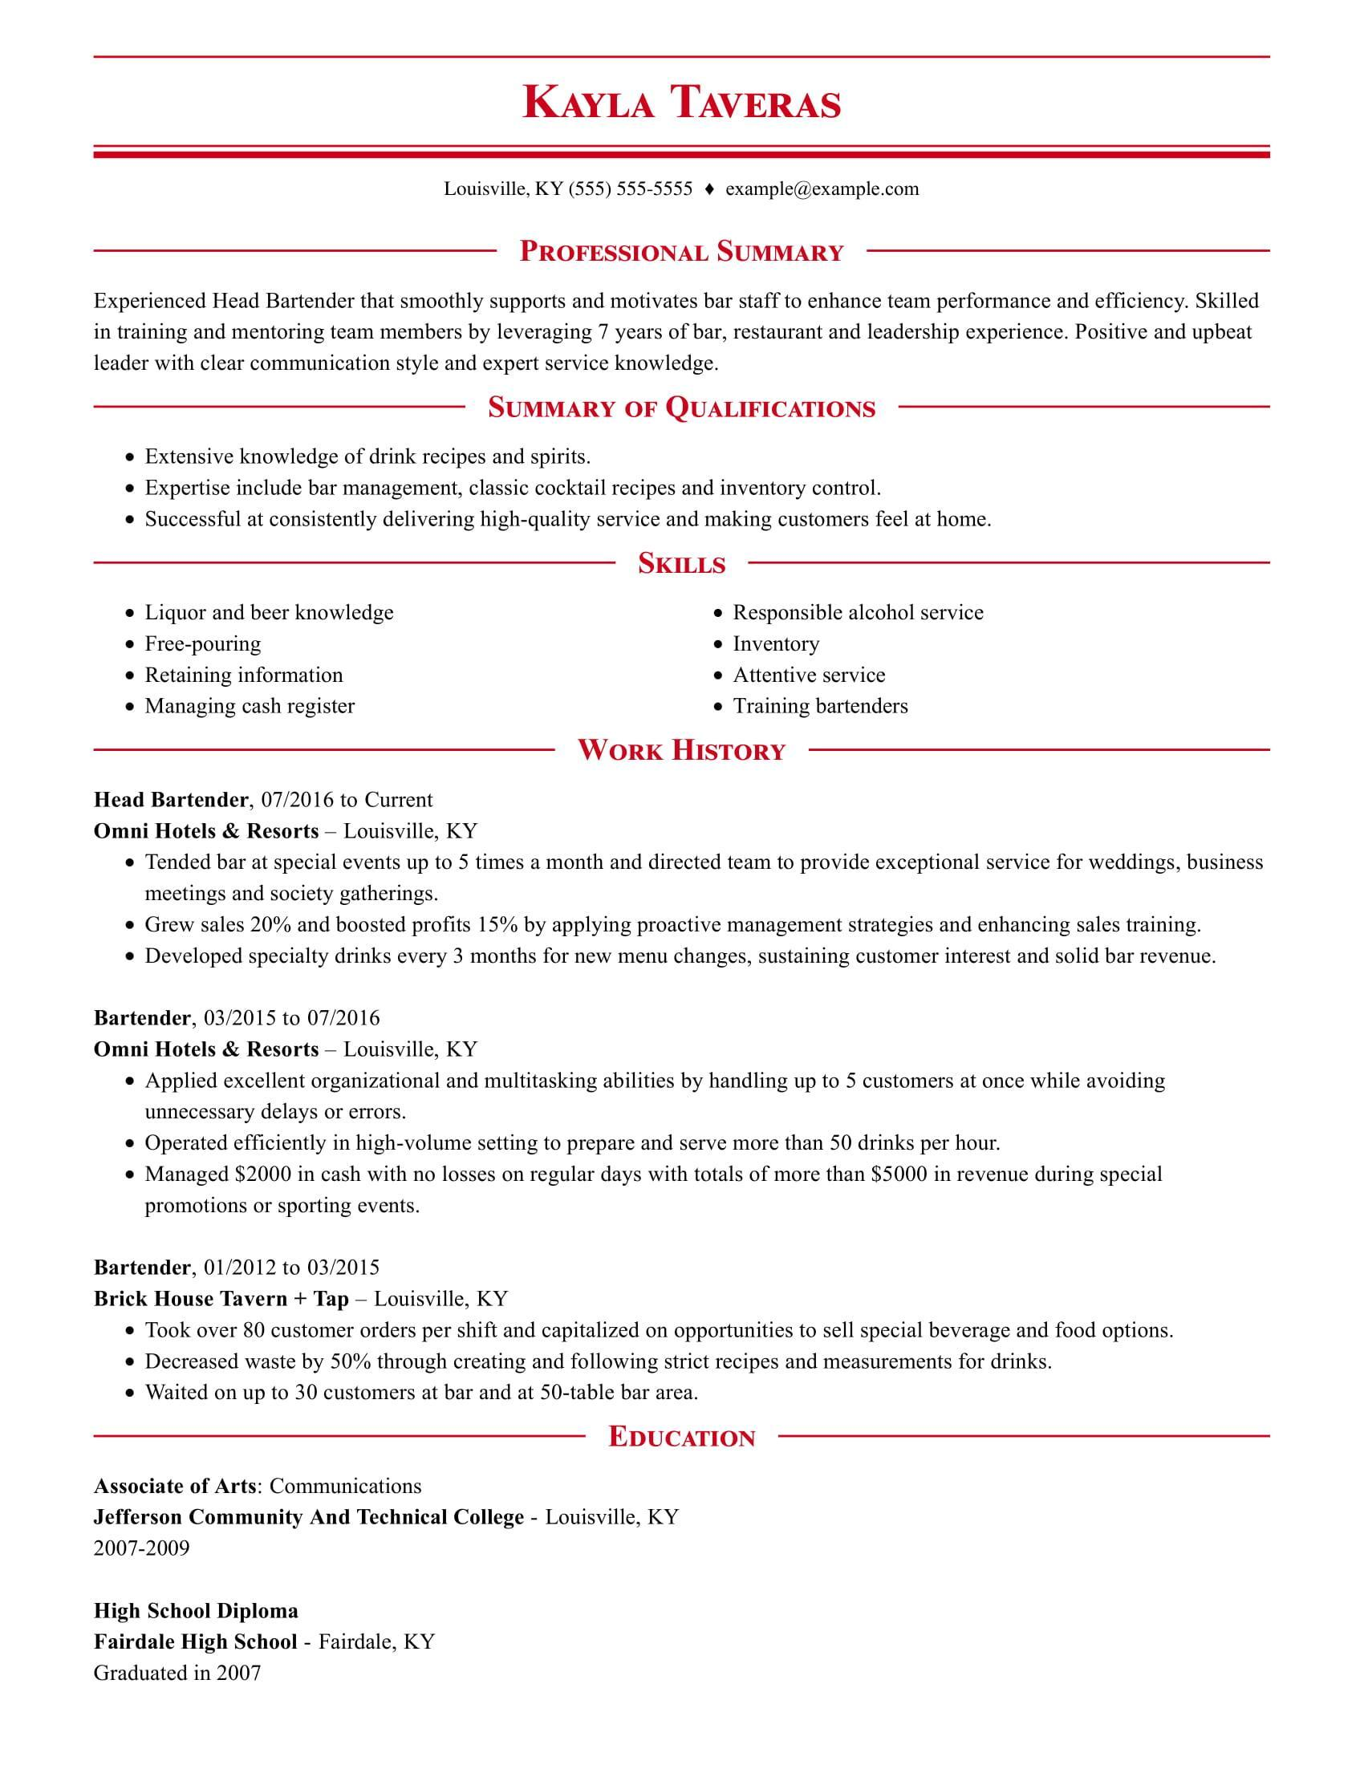
As food service workers climb to mid-level positions, they gain invaluable work experience. Many may also complement this with a degree or certification in a related field. This may range from culinary arts to business or communications.

Combination resume formats, such as in the resume, above allow workers to give equal attention to experience, skills and education. This immediately emphasizes the array of assets the worker will bring to the table.
CTA: Build my resume
Executive-level Food Service Resume Template: Restaurant General Manager
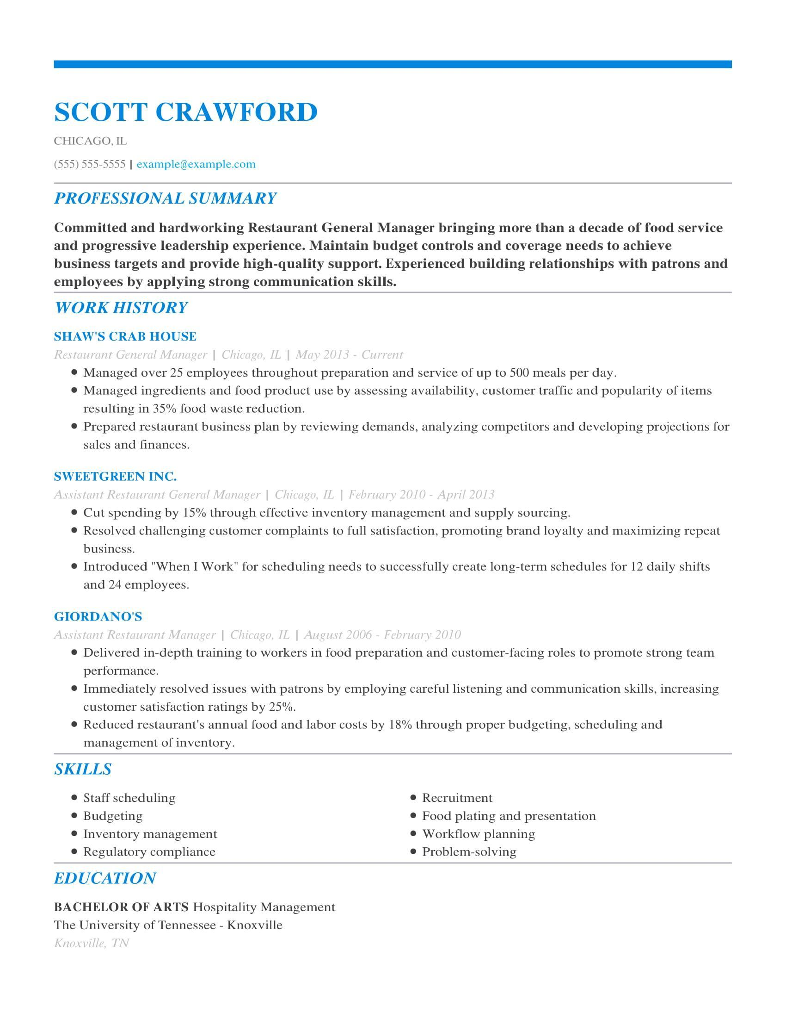
After many years of experience, food service workers want to focus on their stellar work history over their skills. In a chronological resume format, like the one above, the skills section drops below the applicant’s work history and focuses on highlighting high-level skills that are valuable in food service. In the example above, these include staff scheduling, workflow planning, and regulatory compliance, all skills that would be used in a management-level role.
CTA: Build my resume

Blade 8:
Recommended Food Service Cover Letter (no copy)
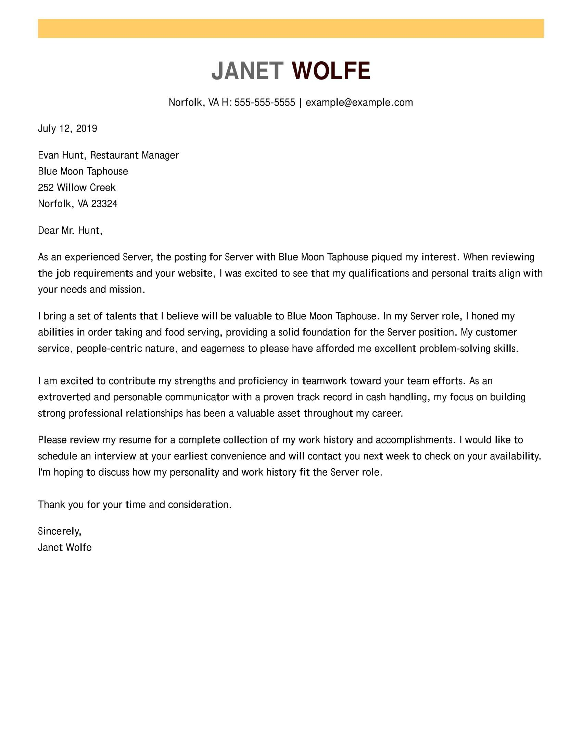
CTA: Build My Cover Letter

Blade 9: TrustPilot [no copy]
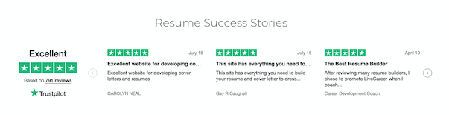

Blade 10: Statistics and Facts About Culinary Jobs

1. Popular Job Titles
Source: Fit Small Business
- Restaurant manager
- Food service worker
- Host/Hostess
- Dishwasher
- Bartender
- Barista
- Server
2. Median Annual Pay by Job Title
(Could be rendered as a chart or graph)

Source: Bureau of Labor Statistics
- Food servers: $21,780
- Host/Hostess: $22,160
- Barista: $22,330
- Bartender: $22,550
- Food service manager: $54,240
3. Pay Structure
Source: The Chicago Tribune
While the federal minimum wage is $7.25, there is an exception for servers. Federal law allows employers to pay servers only $2.13 per hour. This is because employers expect servers to make up the rest of their pay through tips. Servers do so by capitalizing on the social norm of customers paying 20% of the cost of the food in tips. The U.S. government also bans servers from sharing these tips with other workers who do not interact regularly with customers. Because of this, other food service workers tend to have regular rates for their base pay. Some states do set higher minimum wages for the base pay.
4. Best Places to Be a Server
Source: USA Today
Washington has the highest minimum wage in America. Servers must get paid at least $9.32 per hour. Washington is the best state to work as a server, taking into consideration a server’s income, availability of jobs, cost of living, and median household income. Vermont and Massachusetts also make good options.
5. Education Statistics
Source: Bureau of Labor Statistics
Most people in food service have a high school diploma or equivalent, even up to the managerial level. Employees tend to work their way up in food service by gaining experience and skills. However, some people do seek higher education through technical or vocational schools, culinary schools, community college, or four-year universities.
6. College Students and Food Service
Source: CNBC and CBS News
CNBC reports that more college students are now working while attending school. Roughly 70% of students hold down a job while pursuing their degrees. College students often seek out service jobs, such as waiting tables or serving drinks, that require no degree and offer flexible hours. However, many end up staying in these food service positions even after completing their studies. Sometimes difficulties finding a job in their field of study causes this.
CBS News estimates that 14% of servers have a bachelor’s degree, while 16.5% of bartenders have earned the same.
7. Room for Entrepreneurship
Source: ECPI University
Some students have remained in the food service business on purpose with the hope of gaining the experience they need to open their own restaurant. In fact, ECPI University estimates that even back in 2012, 40% of food service managers owned either their own food service franchise or restaurant.
8. Miscellaneous Food Service Workers Facts
Source: Chron
- Elementary and high school cafeterias employ about 4% of America’s food service workers.
- The IRS estimates that 40% of tips go unreported, which implies that salaries for food service workers may be higher than it appears.
- Tips make up about 70% of the salary for most servers, but about 10% for chefs and cooks.
- Tips per hour range from $13 in San Francisco, Boston, and Miami to $7 in Detroit, Seattle, and Minneapolis.

