Blades
- Our Recommended Templates
- Trust Signals
- Create a Driving Resume in 5 Simple Steps
- Get Expert Writing Recommendations for Your Driving Resume
- 6 Dos and Don’ts for Writing a Driving Resume
- Beat the ATS With These Driving Resume Skills
- Driving Resumes for Every Professional Level
- Recommended Driving Cover Letter
- Trustpilot
- Stats and Facts About Driving Jobs

Page title:
Driving Resume Templates

Page subtitle:
Put your career in the fast lane with LiveCareer's library of easy-to-use Driving resume templates and step-by-step guidance.

Blade 1:
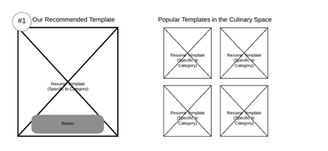
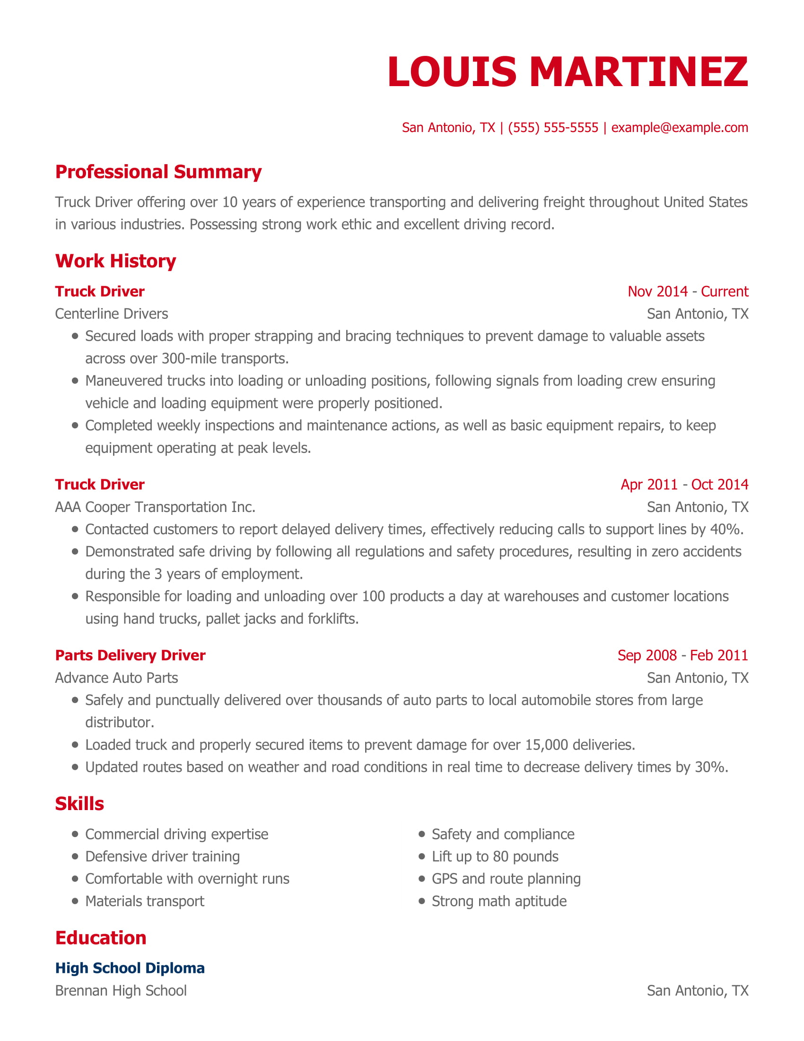

CTA: Customize This Resume

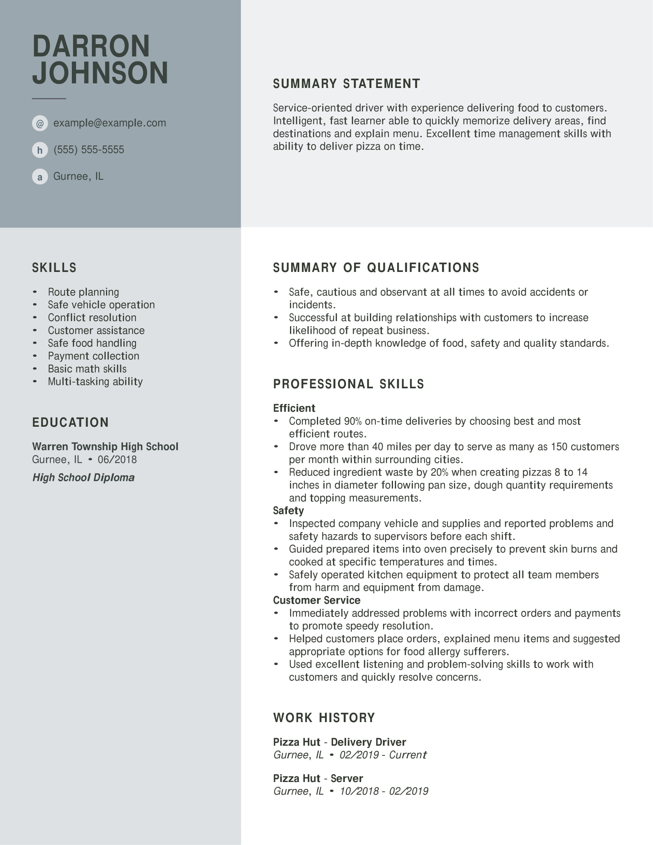

CTA: Customize This Resume

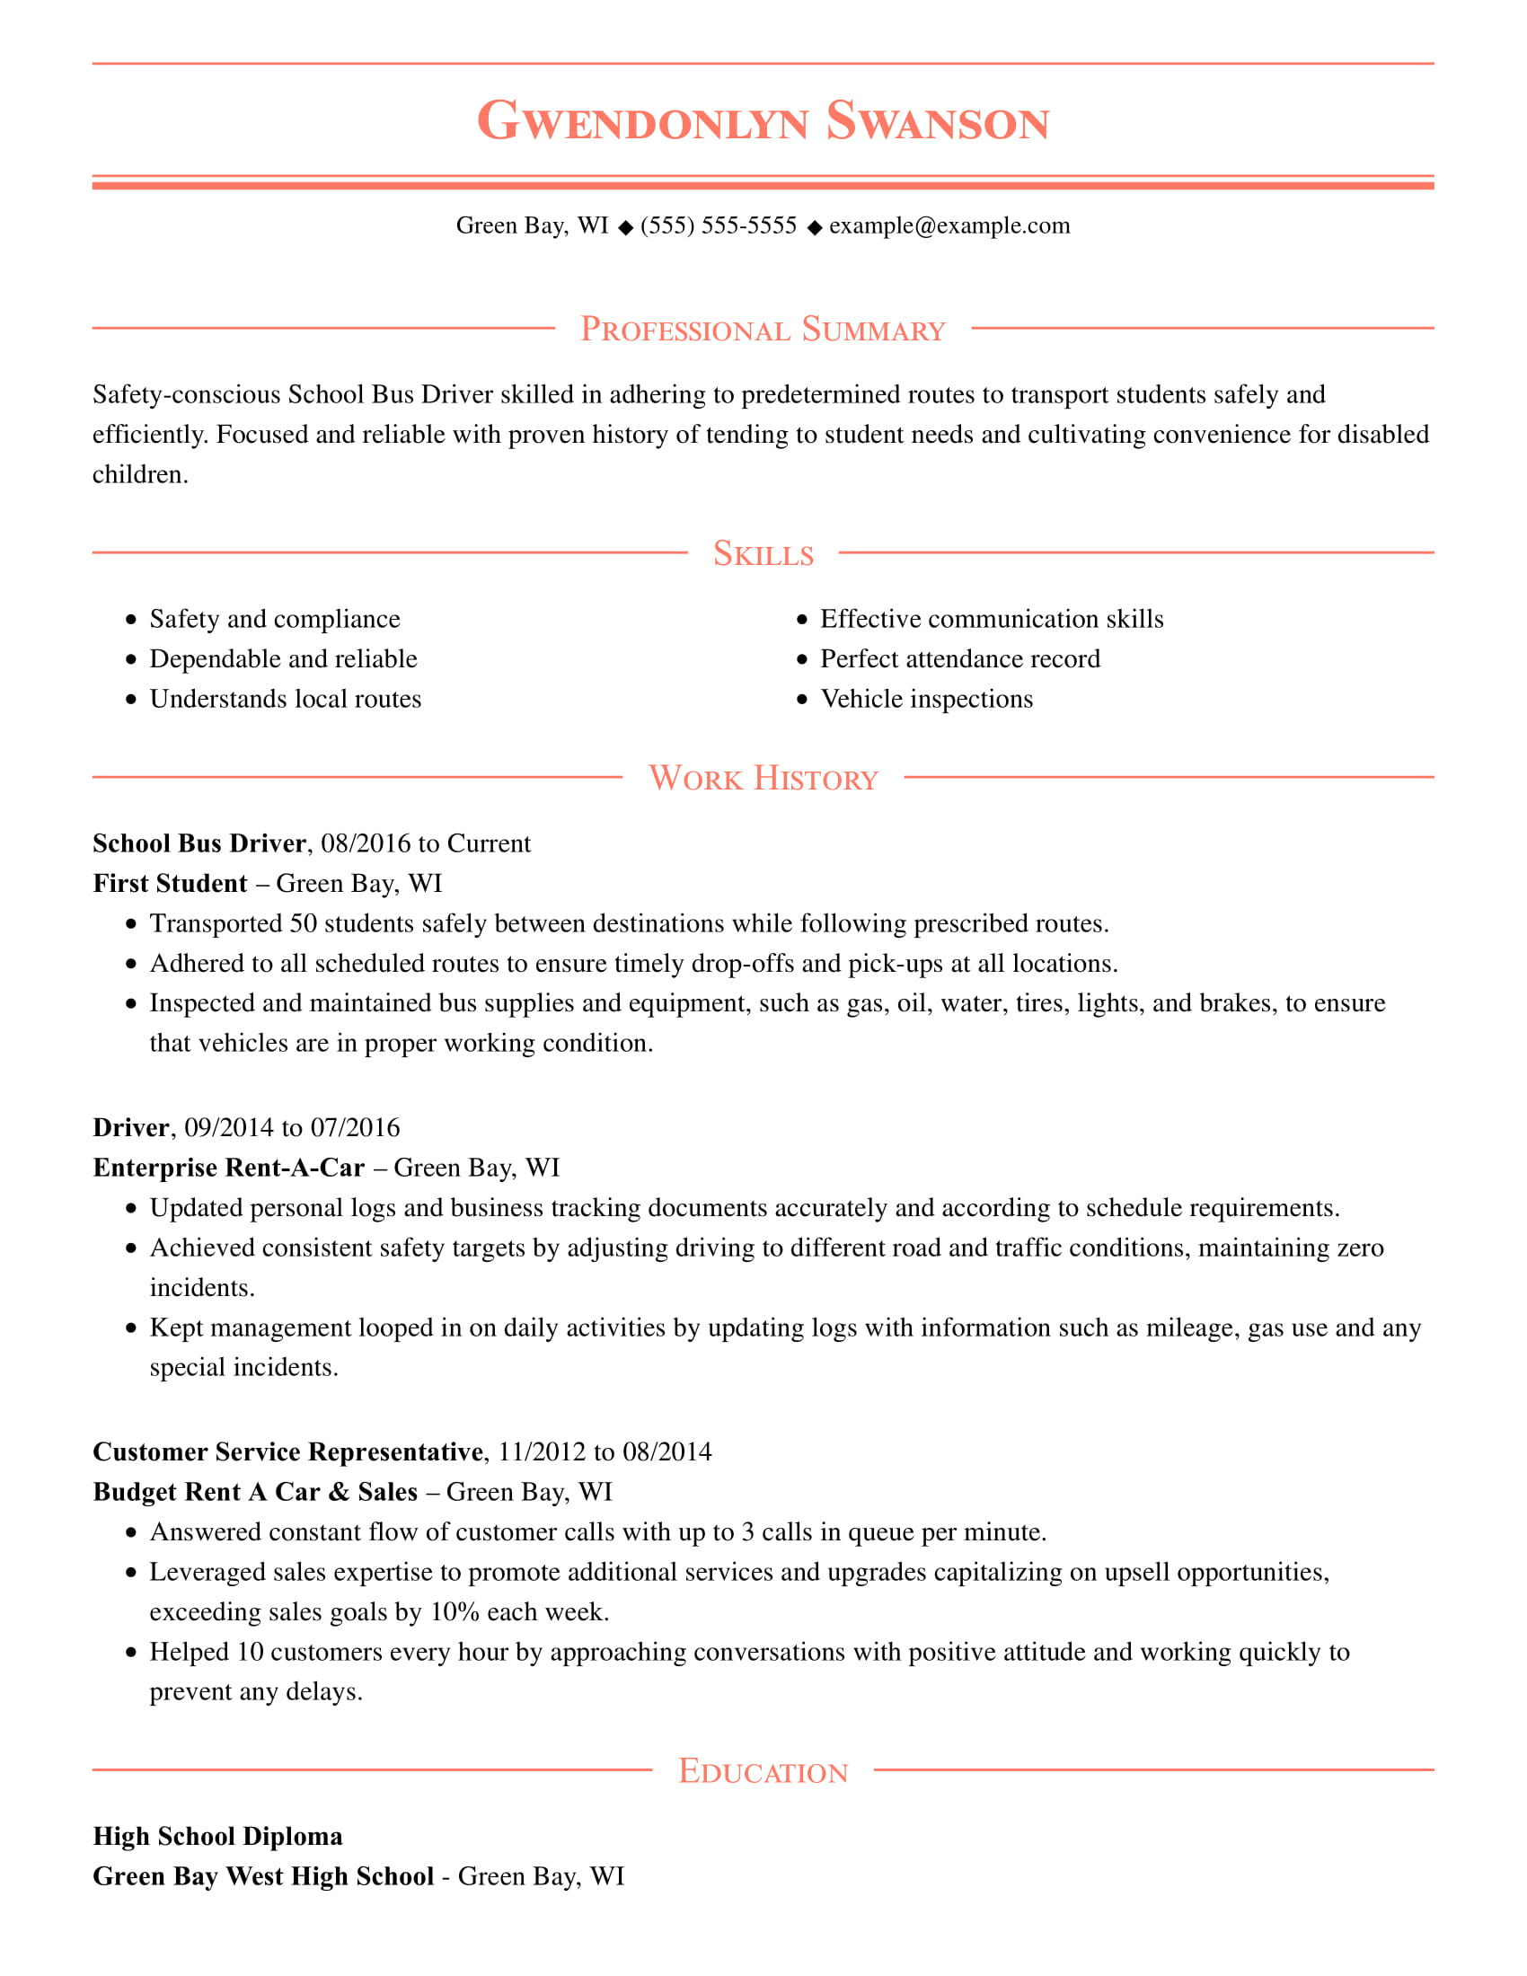

CTA: Customize This Resume

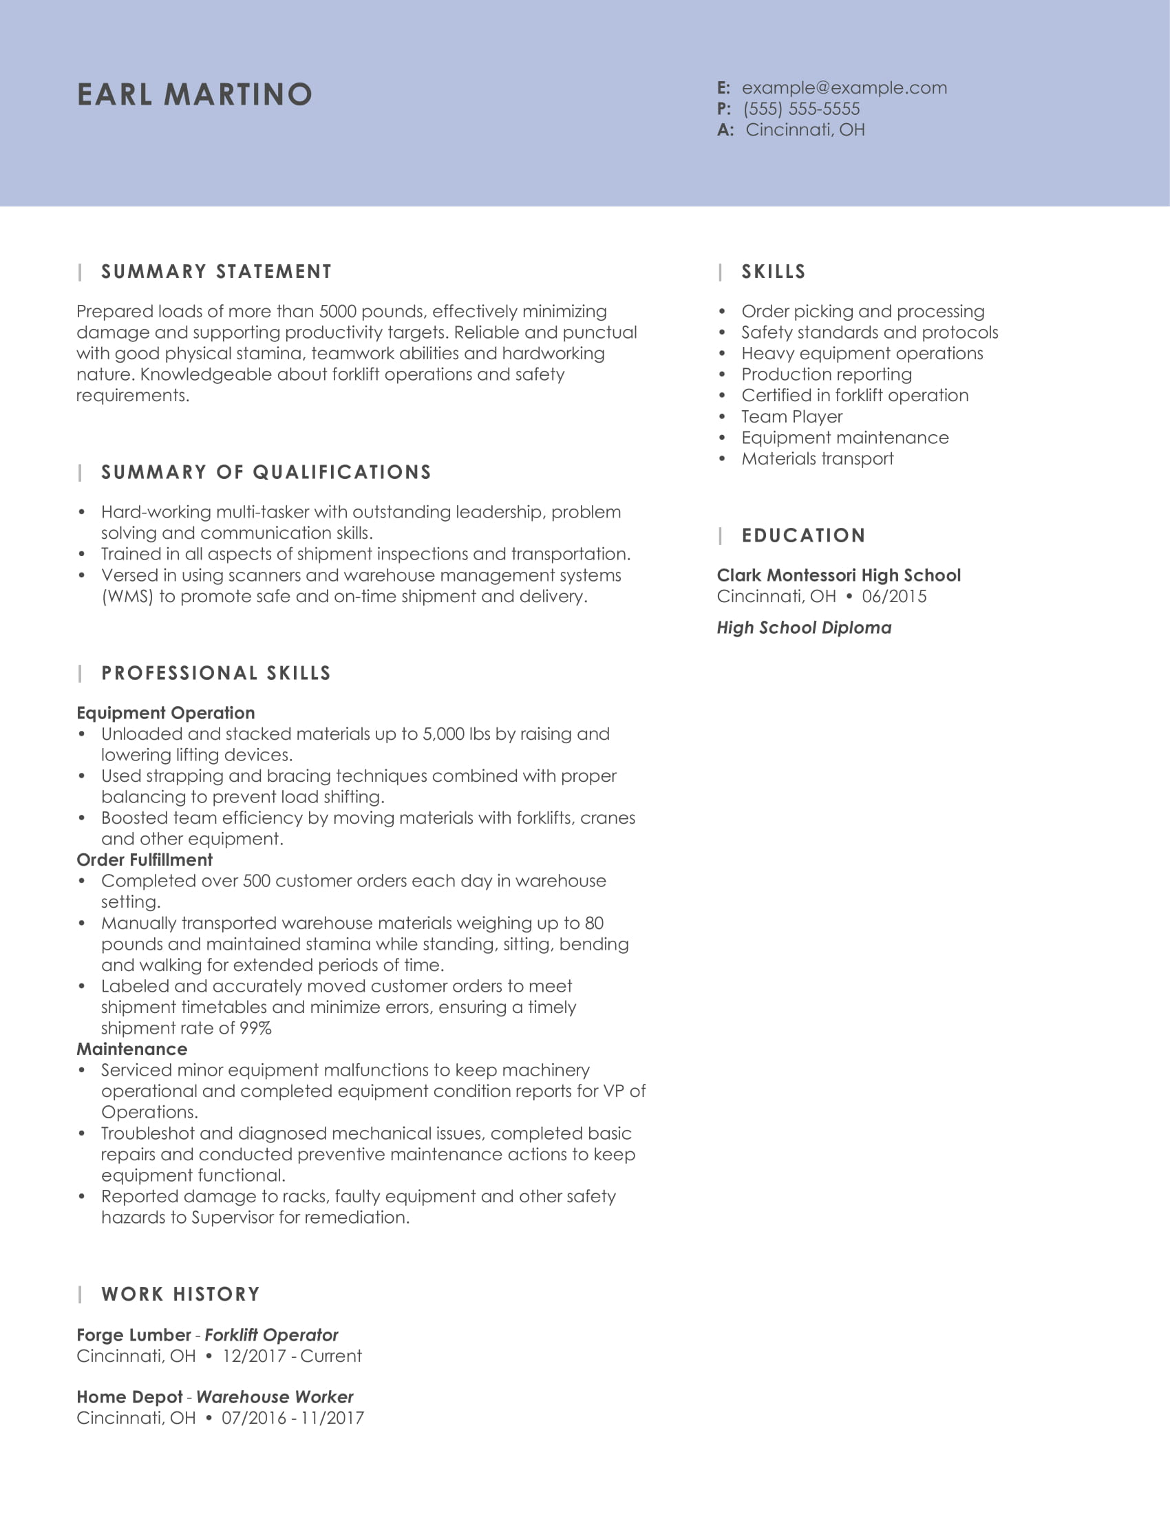

CTA: Customize This Resume

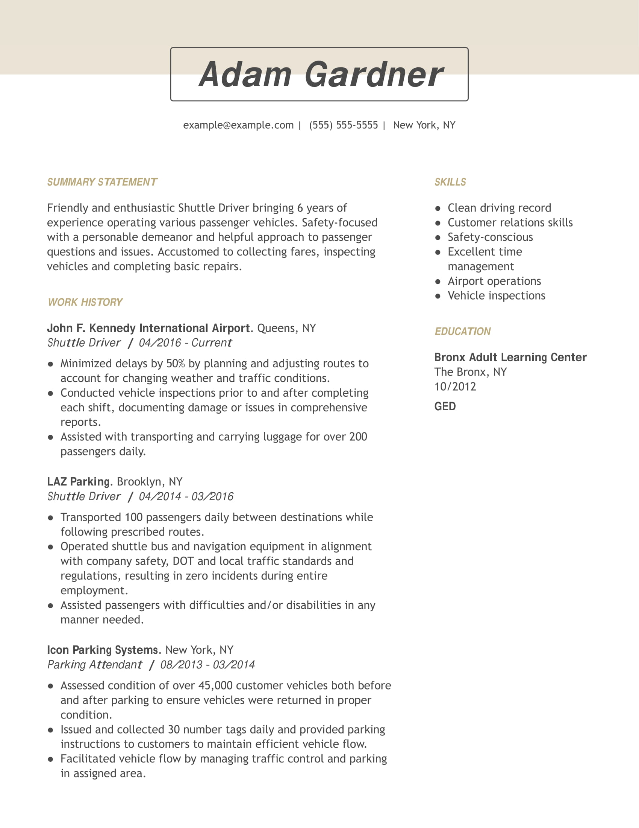

CTA: Customize This Resume

Blade 2:

Blade 3:

Create a Driving Resume in 5 Simple Steps

CTA: Build My Resume

Blade 4:
Get Expert Writing Recommendations for Your Driving Resume

Take the guesswork out of the Driving resume-writing process with LiveCareer's Resume Builder. It provides a host of helpful pre-written text that is crafted by professional resume writers. Modify our suggestions to suit your needs or simply use them as-is in your Driving resume.

Here are six examples of descriptive, action-oriented text that our Resume Builder might suggest for your Driving resume:

- Drove 70-miles per day in service of over 200 customers per month in the greater Chicago area
- Completed 88 percent of deliveries on time by identifying and utilizing the most efficient routes
- Contacted customers directly to address delayed deliveries, reducing calls to customer support by approximately 30 percent
- Inspected company vehicle and identified safety hazards and operational concerns before and after each shift
- Performed routine maintenance and basic repairs on vehicles, minimizing mechanical issues and costs
- Secured oversized loads using strap, brace and cable procedures, reducing the potential for damage by over 90 percent

Blade 5:
6 Dos and Don’ts for Writing a Driving Resume

1. Do choose the appropriate resume template. There's a difference between delivering pizzas and delivering people. When choosing a resume template, select a design that fits the industry you're pursuing. A position where you'll chauffeur private clients throughout the city, for example, calls for a more formal style than a job delivering pies for an artisanal pizzeria.

2. Do choose the resume format that highlights your strengths as a driver. If you have a lengthy driving career and a solid work history, a chronological resume is generally best for demonstrating your experience — and your evolution — as a driver. If you're new to driving, a functional resume is likely the route to take. Use this format to emphasize certifications such as your types of licenses along with skills like navigation and food-handling that will appeal to recruiters.

3. Do use data and metrics to demonstrate your achievements. Instead of writing that you transported passengers daily as an airport shuttle driver, specify that you transported an average 500 people a day. Rather than saying that you loaded and unloaded products using pallet jacks as a truck driver, include that you loaded and unloaded 240 crates of product daily. The more specific you can be, the clearer your accomplishments will be to hiring managers.

4. Do mention any special training you've received. This includes certifications or vehicle licenses you hold, as well as special training, such as defensive driving courses.

5. Don't mention certifications and licenses that aren't relevant to the job at hand. If you're applying for a position driving a school bus, for example, you can omit the fact that you're certified to operate a forklift.

6. Don't limit yourself to just your driving skills. In most cases, there's more to a driving job than sitting behind the wheel. Many positions also incorporate other skills, such as customer service, warehouse management, equipment maintenance, geographical knowledge and math aptitude. When building your resume, examine the job description and customize your skills section accordingly.

7. Don’t use the same resume for every job listing. Instead, tailor your resume to the job you want and highlight the experience and skills listed in the job ad. For example, customer service skills should be featured more prominently in a resume for a limo driving job than on a resume for a lift truck operator position. Scrutinize each job listing carefully to get a better understanding of what your potential employer is looking for and personalize your driving resume accordingly.

8. Don't forget to proofread. Mistakes in your resume signal to potential employers that you lack a skill that is crucial to driving: attention to detail. Demonstrate that you have the focus the road requires by proofreading your resume multiple times. Better still, enlist a friend or family member to read and evaluate it with a fresh set of eyes.

Blade 6:
Beat the ATS With These Driving Resume Skills

One of the biggest hurdles job seekers must overcome are applicant tracking systems (ATS). Employers use an ATS to screen our unqualified candidate for driving jobs by scanning resumes for industry-specific keywords and phrases. The software pre-screens resumes before any human being lays eyes on them, which means that if your resume doesn't contain the right keywords and phrases, it may be kicked to the electronic curb without ever being read by a recruiter.

While small businesses are unlikely to use ATS as part of their driver hiring process, many larger fleets do. Therefore, incorporating relevant keywords is a must. LiveCareer's resume templates make this easy by suggesting language to incorporate in your driving resume. Some of these ATS-friendly keywords might include:

- Clean driving record
- Passenger satisfaction
- OSHA compliance
- Airport operations
- Commercial driving expertise
- Materials transport
- Vehicle inspections
- Knowledge of state roads and highways
- DOT regulations
- Luxury car operation
- Route planning
- Road and vehicle safety and compliance

CTA: Build My Resume

Blade 7:
Driving Resumes for Every Professional Level

Entry-level Driving Resume Template: Taxi Driver

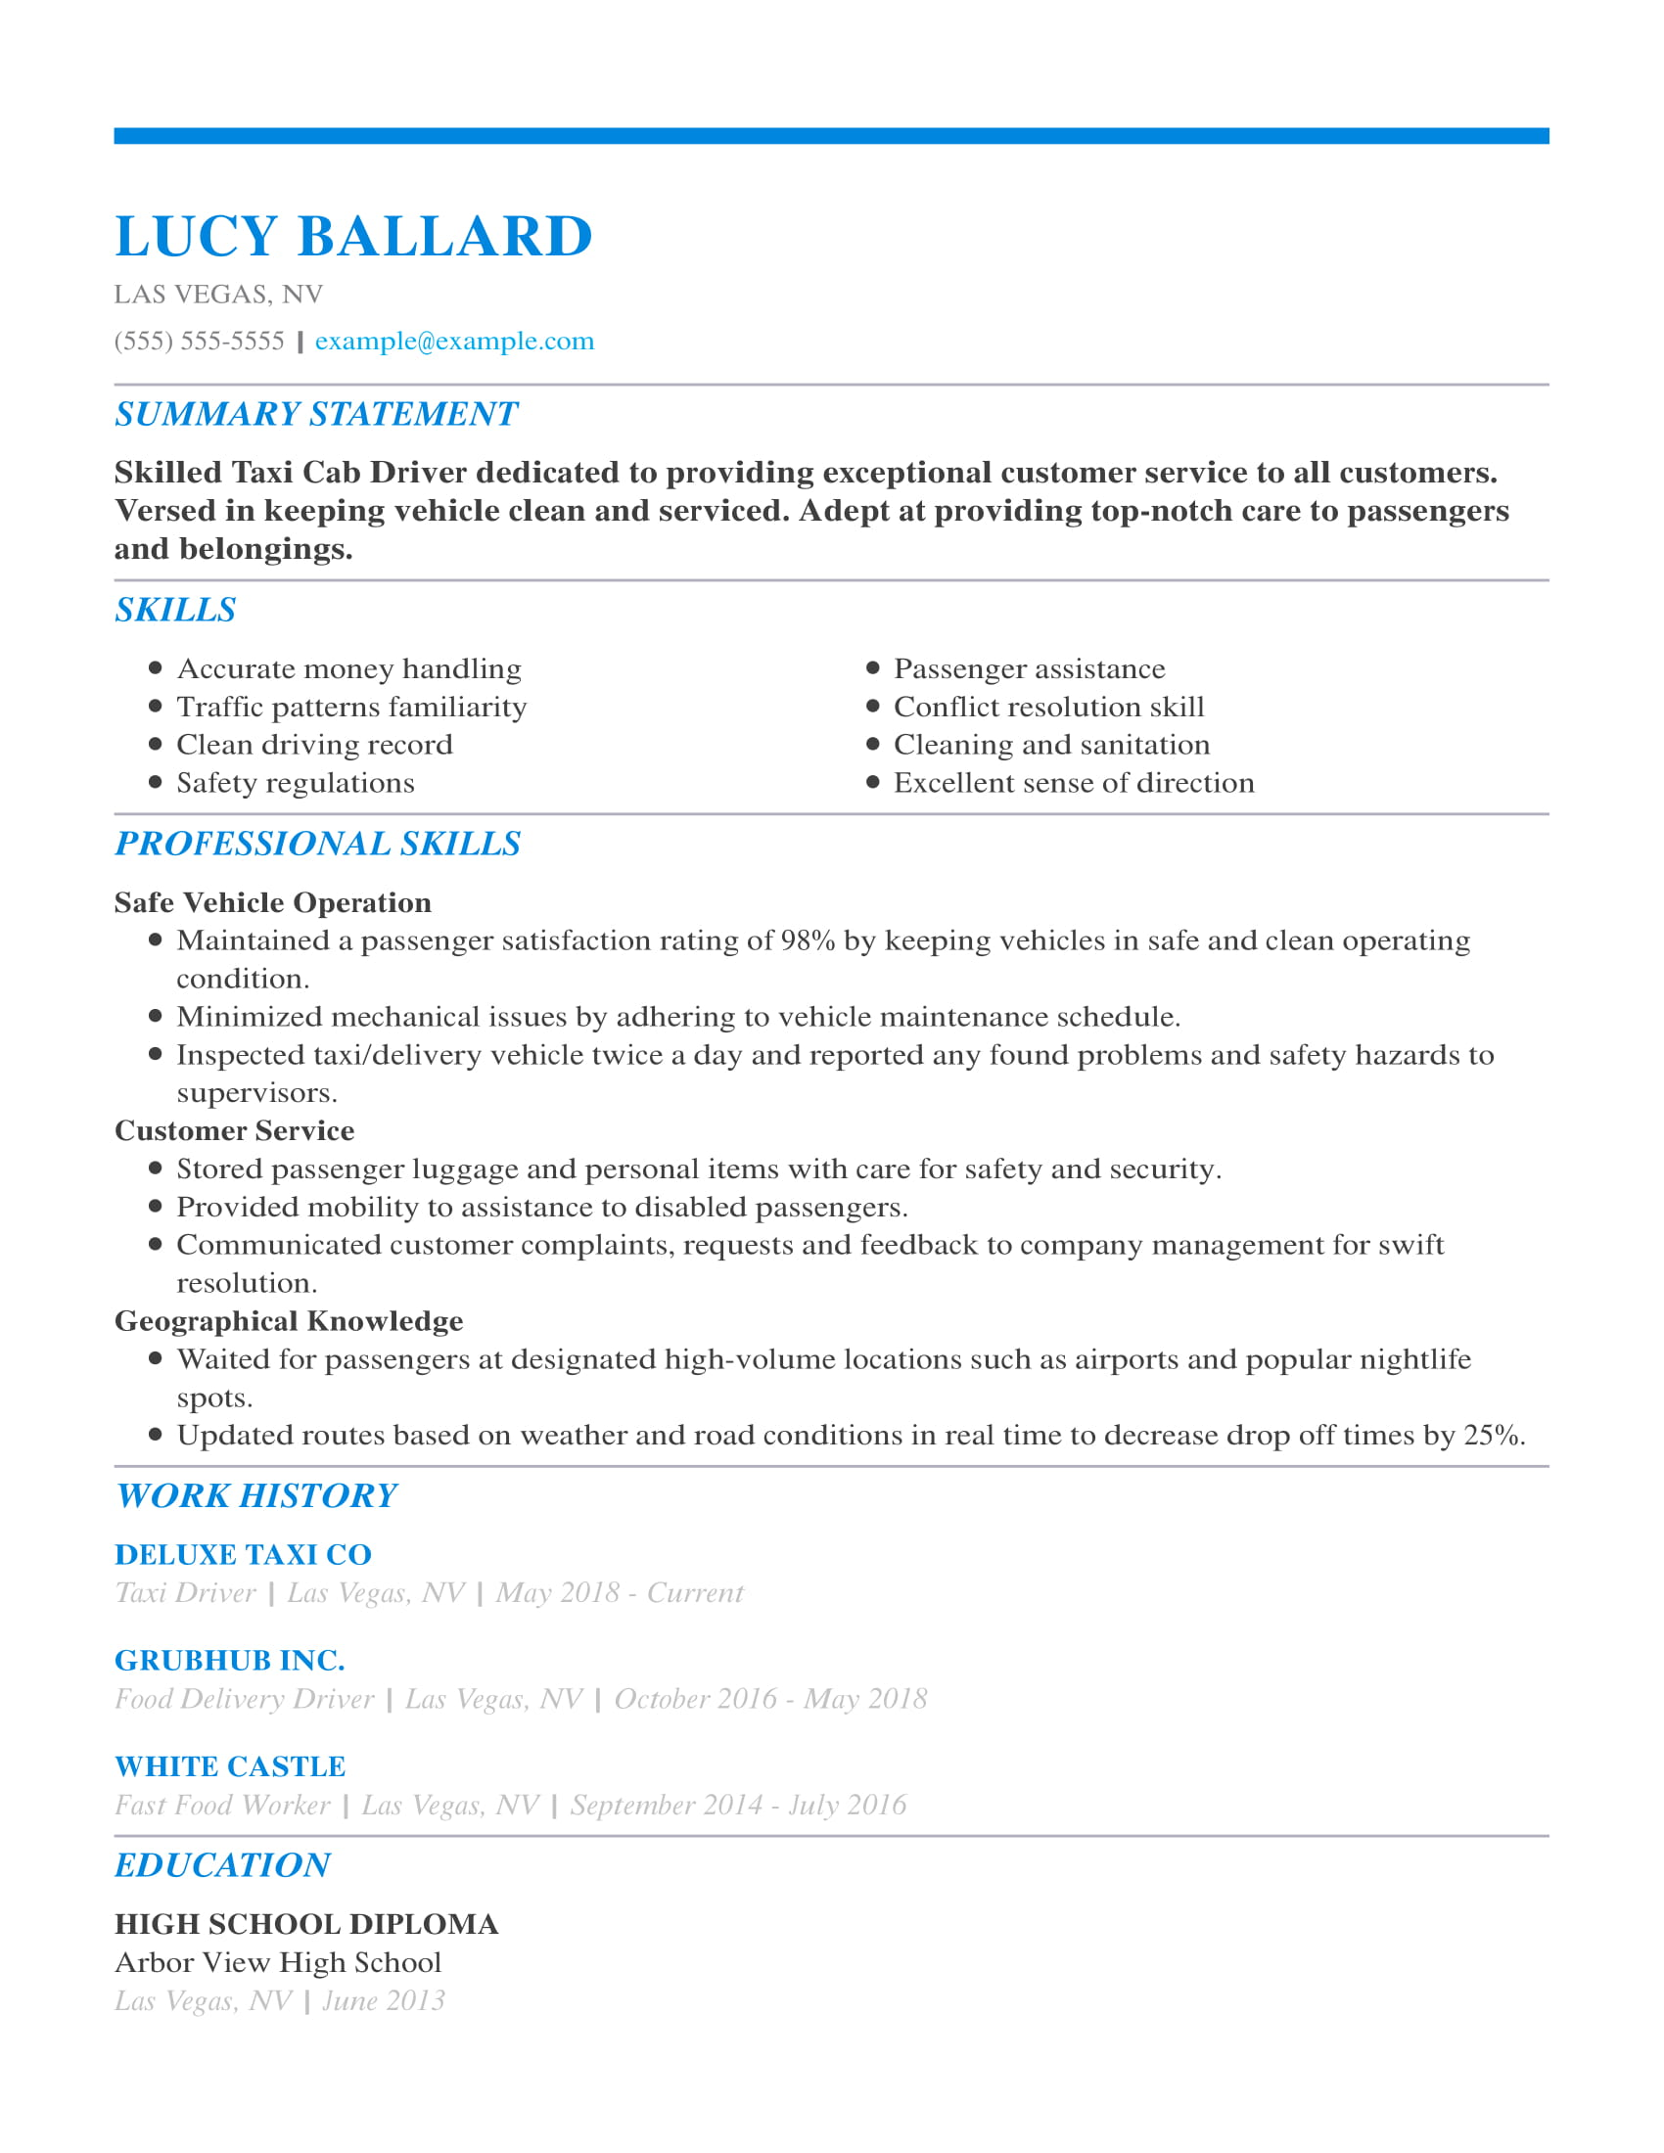

If you're a job seeker with limited driving experience, a functional resume format is an excellent pick because it emphasizes skills above experience.

By devoting the top half of your resume to the comprehensive qualities that make you the right person for the job — such as your pristine driving record, excellent cash handling skills and unsurpassed geographical smarts — and nudging your limited experience further down the page, it draws attention to your abilities and distracts from the fact you're relatively new to the field.

CTA: Build my resume

Mid-career Driving Resume Template: Chauffeur

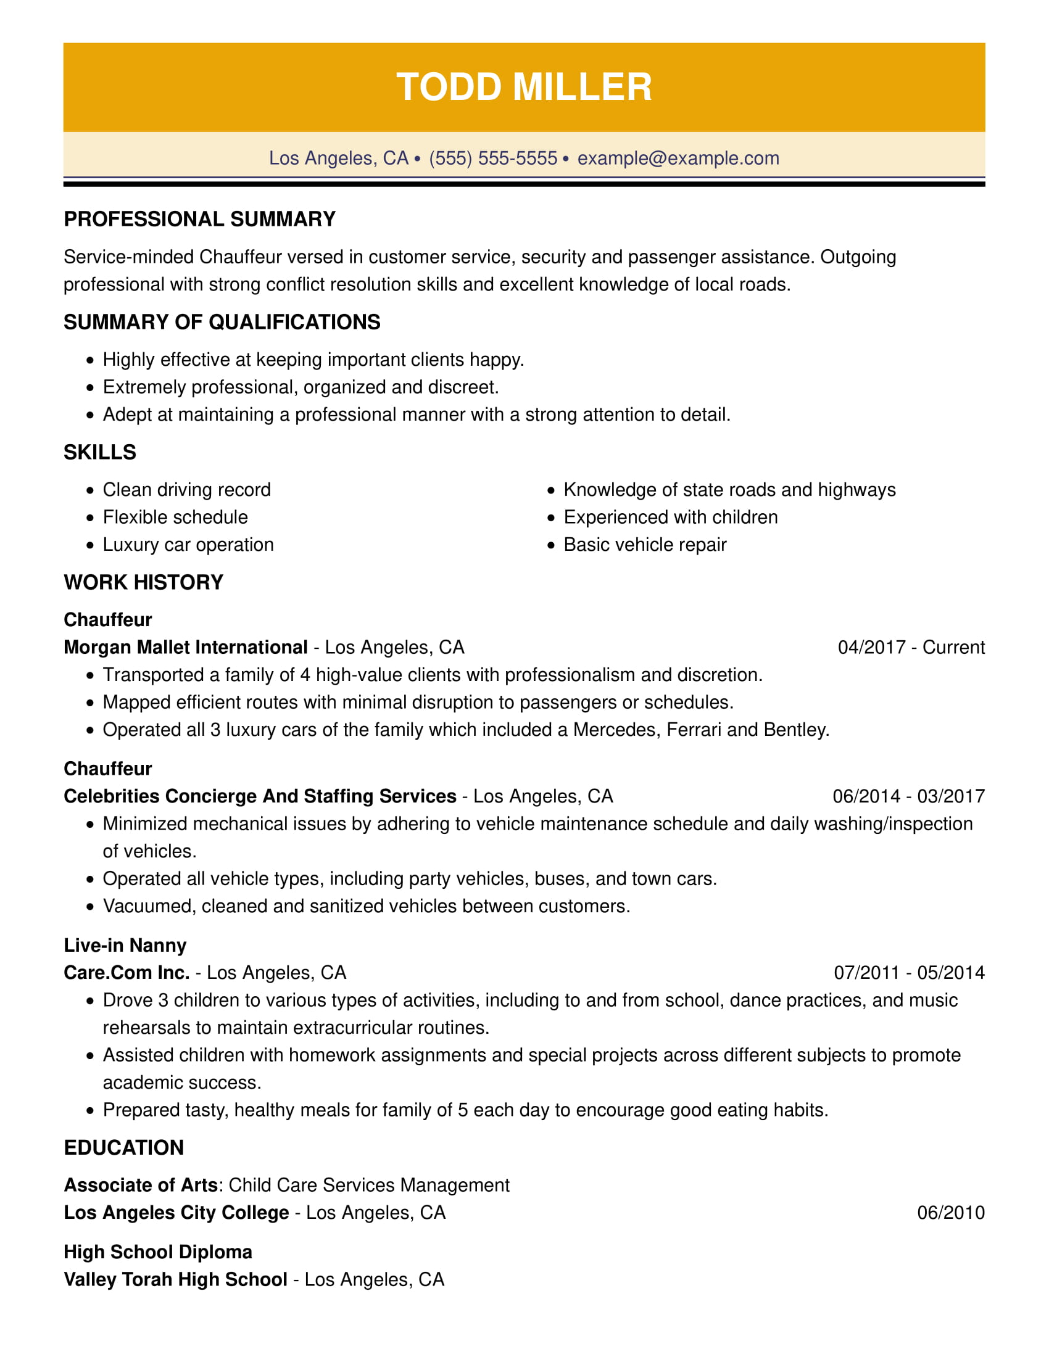

A combination resume, such as the one shown here, allows more experienced drivers to have their cake and eat it, too. As its name suggests, this resume format combines elements of both the functional resume, which focuses on skills, and the chronological resume, which details a driver's work history.

In this case, the resume begins with a brief list of three primary qualifications before transitioning into the job seeker's time-stamped experience. The end result is a thorough but concise overview of his evolution as a chauffeur.

CTA: Build my resume

Executive-level Driving Resume Template: Owner/Operator Truck Driver

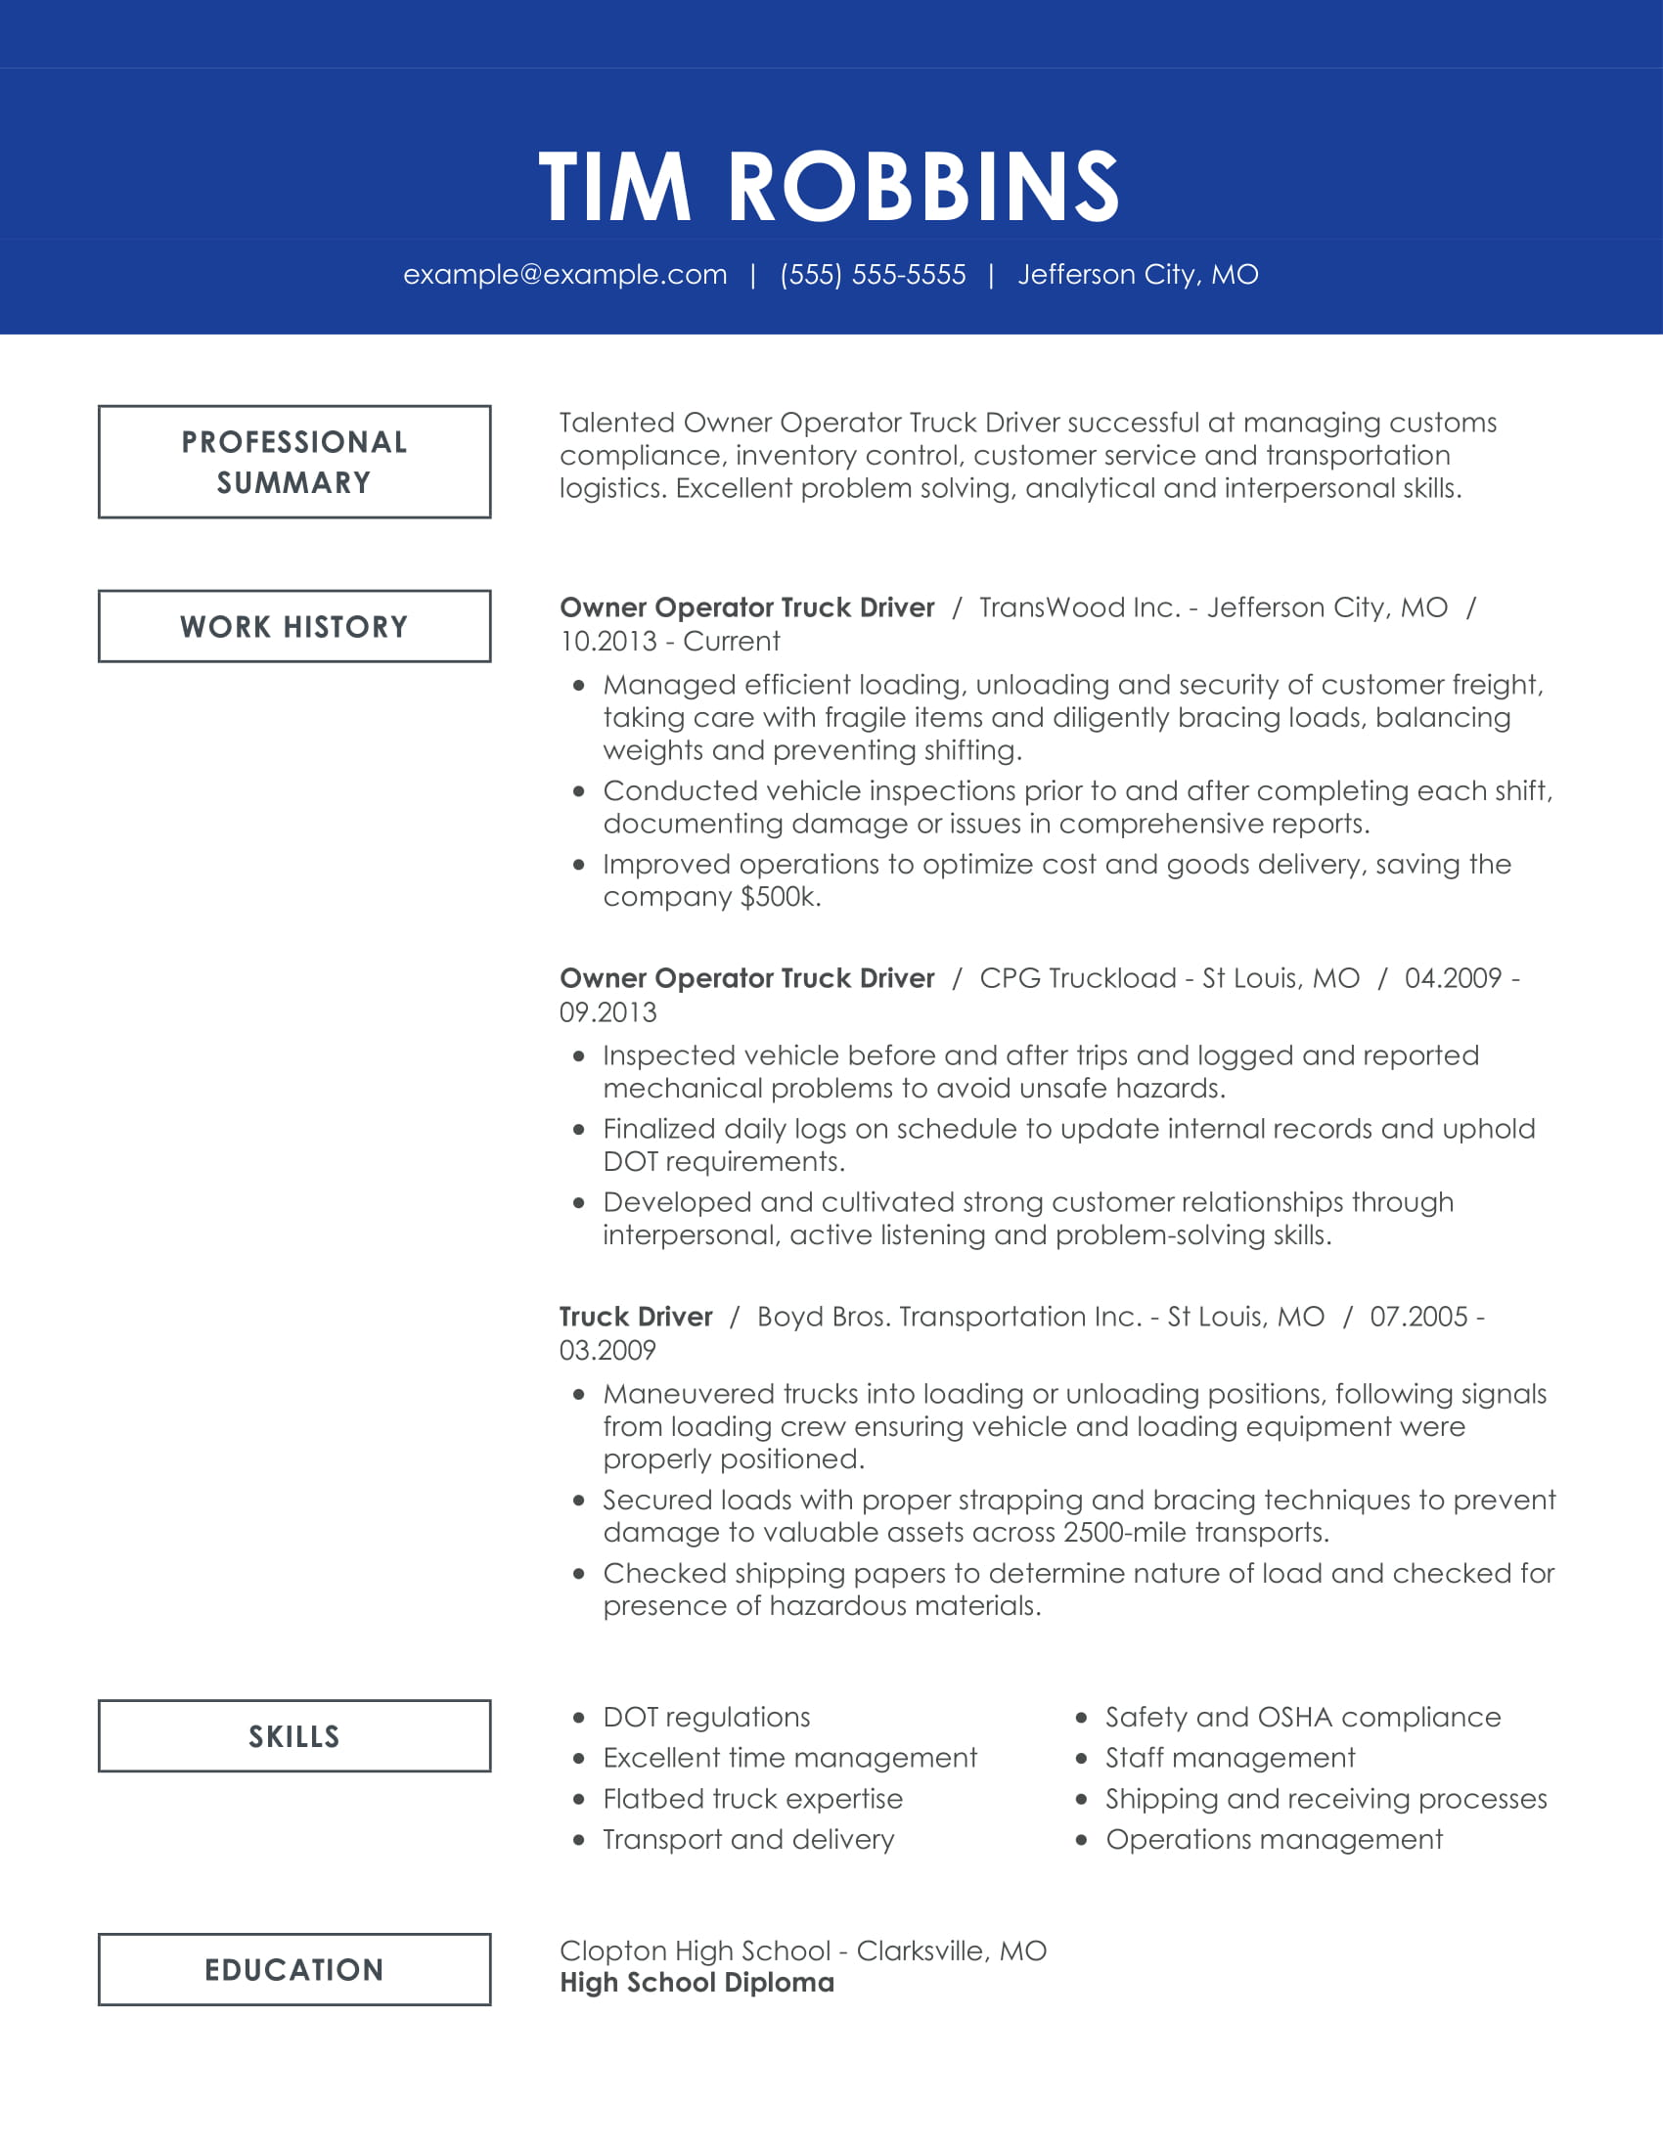

Drivers with experience to spare are wise to opt for a chronological resume that lets them chart their career trajectory. By bringing company names, job titles and years of employment to the forefront, this resume format highlights the depth and breadth of the job seeker's extensive experience on the road.

While skills are still very much included in this example, they take a backseat to a decade's worth of truck driving accomplishments. Here, skills serve as a summary of the detailed work history documented above.

CTA: Build my resume

Blade 8:
Recommended Driving Cover Letter

CTA: Build My Cover Letter

Blade 9: TrustPilot
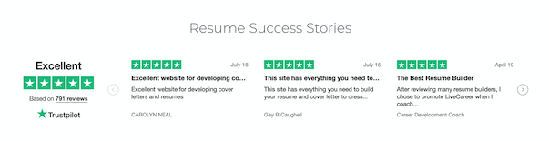

Blade 10:
Statistics and Facts About Driving Jobs

1. Median Annual Pay (2018)
(Could be rendered as a chart or graph)
Source: Bureau of Labor Statistics
- Bus Drivers: $34,450
- Delivery Truck Drivers: $30,500
- Industrial, Heavy and Tractor-Trailer Truck Drivers: $43,680
- Taxi Drivers and Chauffeurs: $25,980

2. Projected Job Growth from 2018–2028
Source: Bureau of Labor Statistics
- Bus Drivers: 5% (average growth)
- Delivery Truck Drivers: 2% (slower than average growth)
- Industrial, Heavy and Tractor-Trailer Truck Drivers: 5% (average growth)
- Taxi Drivers and Chauffeurs: 20% (much faster than average growth)

3. Typical Job Titles
Source: O*Net
- Airport Shuttle Driver
- Chauffeur
- Checker/Loader
- Delivery Driver
- Forklift Technician
- Lift Truck Operator
- Limousine Driver
- Line Haul Driver
- Over-the-road (OTR) Driver
- Production Truck Driver
- Route Supervisor
- Semitruck Driver
- School Bus Driver
- Taxicab Driver
- Tractor Trailer Operator

4. Education Level Required
Source: Bureau of Labor Statistics
- Bus Drivers: High school diploma
- Delivery Truck Drivers: High school diploma
- Industrial, Heavy and Tractor-Trailer Truck Drivers: Postsecondary non-degree award
- Taxi Drivers and Chauffeurs: No formal educational credential required

5. Average Driver Age by Gender
(Could be rendered as a chart or graph)
Source: DataUSA
- Bus Drivers: 54.5 for men, 49.8 for women
- Delivery Truck Drivers: 45.3 for men, 41.8 for women
- Industrial, Heavy and Tractor-Trailer Truck Drivers: 40.5 for men, 42.6 for women
- Taxi Drivers and Chauffeurs: 47.1 for men, 45.1 for women

6. Gender Diversity
(Could be rendered as a chart or graph)
Source: DataUSA
- Bus Drivers: 54% male, 46% female
- Delivery Truck Drivers: 93% male, 7% female
- Industrial, Heavy and Tractor-Trailer Truck Drivers: 92% male, 8% female
- Taxi Drivers and Chauffeurs: 83% male, 17% female

7. Average Salary Disparity by Gender
Source: DataUSA
- Bus Drivers: Male drivers make 23.3% more
- Delivery Truck Drivers: Male drivers make 55.8% more
- Industrial, Heavy and Tractor-Trailer Truck Drivers: Male drivers make 10.7% more
- Taxi Drivers and Chauffeurs: Male drivers make 33.7% more

8. Annualized Turnover Rate as of 2017
Source: American Trucking Association
- Large Fleets ($30 million or more in revenue): 88%
- Small Fleets (less than $30 million in revenue): 80%

