Blades
- Our Recommended Templates
- Trust Signals
- Create an Administrative Resume in 5 Simple Steps
- Get Expert Writing Recommendations for Your Administrative Resume
- 8 Dos and Don’ts for Writing an Administrative Resume
- Consider These Skills for Your Administrative Resume
- Administrative Resumes for Every Professional Level
- Recommended Administrative Cover Letter
- TrustPilot
- Statistics and Facts About Administrative Jobs

Page title:

Administrative Resume Templates

Page subtitle:

Get step-by-step guidance with LiveCareer’s administrative resume templates. Use our simple Resume Builder to create the perfect resume for getting the job you want in the administrative field.

Blade 1
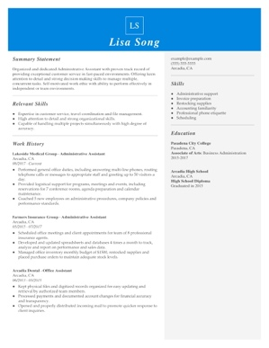

CTA: Customize This Resume

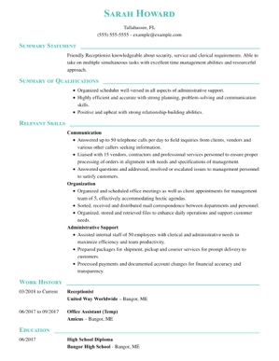

CTA: Customize This Resume
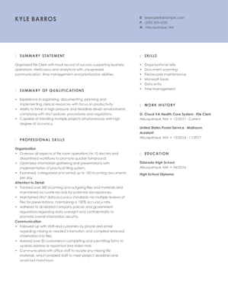

CTA: Customize This Resume
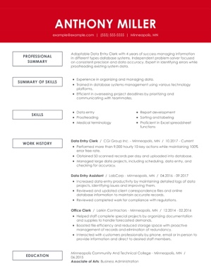

CTA: Customize This Resume
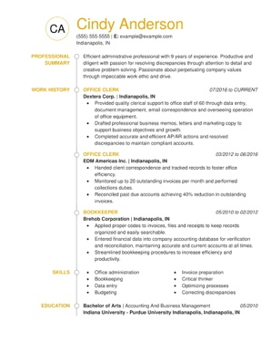

CTA: Customize This Resume

Blade 2

Blade 3

Create an Administrative Resume in 5 Simple Steps

CTA: Build My Resume

Blade 4

Get Expert Writing Recommendations for Your Administrative Resume

LiveCareer helps job seekers find the right way to word their resumes for jobs in the administrative field. Our Resume Builder provides industry-specific content and pre-written text created by certified resume writers. With our guidance, resume writing is faster and much easier than ever.

If goal is an administrative role, you need to use action words to show off your organizational, time management and customer service skills. Here are some examples our Resume Builder might recommend to job seekers who are writing an administrative resume:

- Performed general office duties, including answering multi-line phones, routing telephone calls or messages to appropriate staff, and greeting visitors
- Scanned files and eliminated outdated records
- Created reports, correspondence and spreadsheets with Microsoft Office programs
- Greeted arriving members professionally by first name
- Managed travel itineraries and logistics for accommodations for 65+ employees
- Established efficient workflow processes, monitored daily productivity and implemented modifications to improve overall effectiveness of personnel and activities

Blade 5

8 Dos and Don'ts for Writing an Administrative Resume

- Do point out your experience with computer software and technology. Administrative workers should be capable in most productivity software, such as Microsoft Word and Excel. They should also know scheduling software, such as Outlook or Google Calendar. Organizational tools or apps, such as Dropbox or Evernote, are also essentials in the administrative job seeker's arsenal of skills.

- Do include details about problem solving. An administrative resume should provide examples of high-level problem solving. Managing office supply orders and inventory one way an administrative worker might solve problems. Other workers in this field demonstrate problem-solving skills by being a key contact in an office and answering questions from other employees.

- Do emphasize your interpersonal skills. Interpersonal skills are important to recruiters for jobs in this field. Candidates can emphasize their interpersonal strengths by detailing duties related to greeting office visitors, scheduling meetings with staff members and delivering outstanding customer service.

- Do give information about your organizational abilities. Administrative assistants, data clerks, receptionists and many other job titles in this field rely on organization to succeed. Your resume should have plenty of details about your ability to organize, such as experience creating filing systems, making travel arrangements, organizing events or managing executive calendars.

- Don’t forget to customize the resume for the specific administrative position. Administrative jobs are available across all industries so it's important to make your resume specific to the industry and company, not just to the job title. For example, working in real estate requires a specific skillset, including as scheduling showings, coordinating with agents and communicating with potential buyers and lenders. Admins in other fields will need to emphasize other skills.

- Don’t miss an opportunity to show off your attention to detail. Attention to detail in administrative jobs is a must. Don't mess up by making careless errors on your resume. Even if you have an impressive work history, grammar and spelling errors make it evident that your attention to detail is lacking.

- Don’t sell yourself short on your accomplishments. Candidates for administrative jobs should tout their accomplishments to stand out in this competitive field. Show off your productivity skills by noting your lightning-fast typing speed and ability to man a multi-line phone system.

- Don’t forget the enthusiasm. Because personality and friendliness matter in this field, feel free to show a little bit of yourself in your resume. Your professional summary at the top of your resume should convey your ambition and dedication to supporting staff members.

Blade 6

Consider These Skills for Your Administrative Resume

One challenge for job seekers in the administrative field is tackling the applicant tracking system. Because administrative jobs exist across industries, the ATS, which automatically reviews resumes for specific key words and phrases related to the role, is something candidates will likely encounter, especially at larger companies.

LiveCareer's Resume Builder makes it easy for candidates to optimize their administrative resume for an ATS by suggesting with specific details recruiters seek. Here are examples of some of the skills the our builder might recommend to help and administrative resume pass an ATS:

- Personable and friendly with staff and customers
- Positive attitude
- Customer-service skills
- Self-starter who takes initiative
- Understanding of digital filing systems
- Expertise with Microsoft Office suite
- Accurate and quick with data entry
- Strong writing and correspondence skills
- Skilled with updating business social media pages
- Ability to manage an appointment calendar

CTA: Build My Resume

Blade 7

Administrative Resumes for Every Professional Level

Entry-level Administrative Resume Template: Data-Entry Keyers

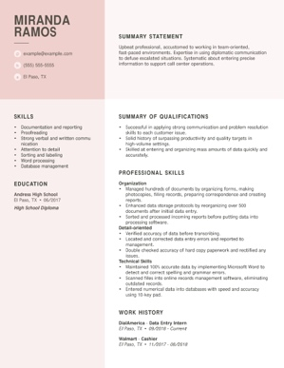

This entry-level data entry job seeker doesn't have much professional experience, with some time as a retail cashier and a few months as an intern. For that reason, the candidate focuses more on her comprehensive skills and qualifications by using a functional resume template.

This job seeker puts desirable administrative skills at the forefront of her resume, such as organization, attention to detail and technical skills. She also shines with an effective summary statement that shows off her teamwork skills, positive attitude and conflict-resolution expertise.

CTA: Build my resume

Mid-career Administrative Resume Template: Executive Administrative Assistant

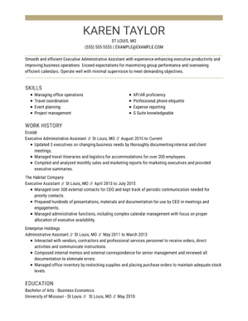

This job seeker, who is applying for an executive administrative assistant role, shows a candidate with several years of experience. She emphasizes both her valuable skills and experience by using a combination resume. The candidate's work history shows a steady career progression from an administrative assistant to an executive administrative assistant at her most recent job.

This resume paints a [picture of a worker who is self-sufficient and has experience getting results when working with executives by giving a thorough overview of how the applicant has brought value to her past roles.

CTA: Build my resume

Executive-level Administrative Resume Template: Office Manager

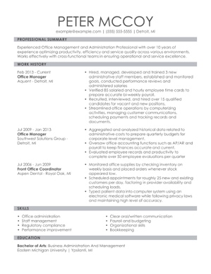

In this resume, the key focus is on the applicant’s many years of experience. He demonstrates his leadership skills and ability to get results while managing a busy office. The candidate also lists his college degree in business administration, an important credentials for some upper-level admin roles. His work history details an increasing level of responsibility and a steady career trajectory.

This applicant shows off the importance of using quantifiable data, especially in fields dealing with payroll, managing employees and training them. By using these metrics on his resume, he demonstrates a readiness for his next challenge in an administrative role.

CTA: Build my resume

Blade 8

Recommended Administrative Cover Letter
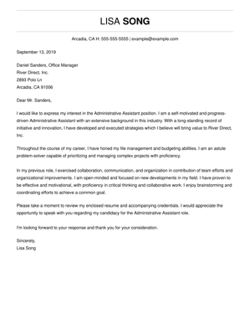

CTA: Build My Cover Letter

Blade 9

TrustPilot

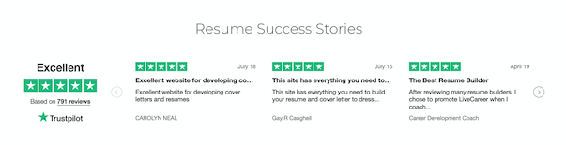

Blade 10

Statistics and Facts About Administrative Jobs

Popular Administrative Job Titles and Number of Workers

- Administrative Assistant – 3,786,800
- Office Clerk – 3,158,500
- Accounting Clerk – 1,707,700
- Information Clerk – 1,484,300
- Receptionist – 1,101,500

Source: Bureau of Labor Statistics

Popular Industries That Employ Administrative Staff and Number of Workers

*This could be rendered as a chart or graph

- Hospitals – 911,596
- Banks and Finance – 710,774
- Insurance Companies – 692,642
- Grocery Stores – 616,232
- Retail Department and Discount Stores – 597,792

Source: Data USA – U.S. Census Data

Highest and Lowest Pay by Industry for Administrative Workers

Highest

- Software Publishing - $75,181
- Pipeline Transportation - $70,185
- Oil and Gas Extraction - $66,940

Lowest

- Bowling Centers - $13,207
- Beauty Salons - $13,373
- Nail Salons - $15,466

Source: Data USA – U.S. Census Data

Job Outlook by Job Title 2018-2028

- Receptionist – 5% growth
- Accounting Clerk – 4% decline
- Administrative Assistant – 7% decline
- Information Clerk – no change
- Office Clerk – 4% decline

Source: Bureau of Labor Statistics

Median Pay for Popular Job Titles

*This could be rendered as a chart or graph

- Receptionist – $29,140
- Accounting Clerk – $40,240
- Administrative Assistant – $38,880
- Information Clerk – $34,520
- Office Clerk – $32,730

Source: Bureau of Labor Statistics

Race and Ethnicity Data for Administrative Workers

- White – 73.4%
- Black – 14%
- Asian – 4.54%
- Other – 4.44%
- Two or more races – 2.64%
- American Indian – .0524%
- Pacific Islander – .0232%

Source: Data USA – U.S. Census Data

Gender Makeup of Administrative Jobs

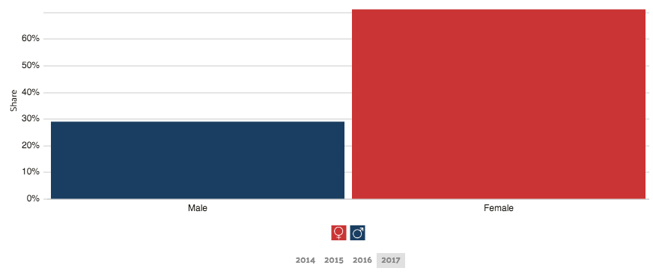

Source: Data USA – U.S. Census Data

College Degree Majors for Administrative Workers

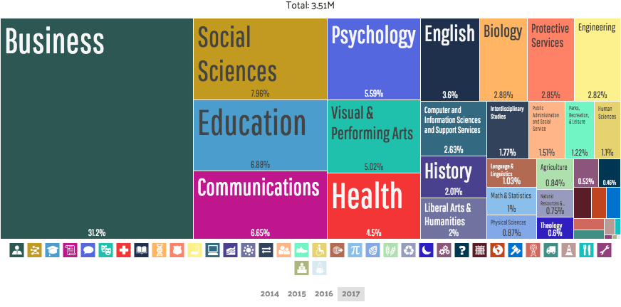

Source: Data USA – U.S. Census Data

