LC – P1P
Category Page Assignment Brief

Related Tickets: [MOU1]

Blades
- Our Recommended Templates
- Trust Signals
- Create a [Category] Resume in 5 Simple Steps
- Get Expert Writing Recommendations for Your [Category] Resume
- 6 Dos and Don’ts for Writing a [Category] Resume
- Beat the ATS with These [Category] Resume Skills
- [Category] Resumes for Every Professional Level
- Recommended [Category] Cover Letter
- Trustpilot
- Stats and Facts About [Category] Jobs

Page title:
[Category] Resume Templates

Page subtitle:
Please write a subtitle of up to 30-words.

Blade 1: (no copy)
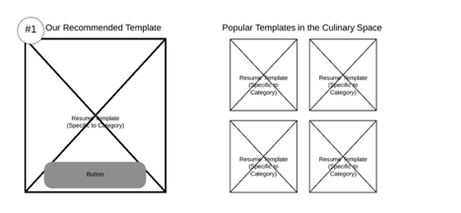
BKA: Five resumes will be provided to you for this section. Please drop them into the document and place a CTA under each resume that reads “Customize This Resume.”

CTA: Customize This Resume

Blade 2: (no copy)

Blade 3: (no copy)

Create a [Category] Resume in 5 Simple Steps

CTA: Build My Resume

Blade 4:
Get Expert Writing Recommendations for Your [Category] Resume

- THIS SECTION MUST BE UNIQUELY WRITTEN FOR EVERY CATEGORY PAGE. Do not copy the flow of the pilot pages for this blade.

- Please write no more than 150 words, total. (This includes the bullet point examples below.)

- Explain that these professionally-written, category specific phrases are designed to make the writing process simple, emphasize our resume builder’s pre-written text suggestions and mention that the pre-written text is crafted by certified resume writers
- Provide 6-10 examples of content our builder might recommend for a resume in this category. These can be pulled from the resumes provided to you or can be generated through the builder.
- Each page needs to have unique copy in this blade. Please do not formulaically follow the flow of the content on the pilot page. Rather, write this copy in the way that best makes sense for your category.

Blade 5:
6 Dos and Don’ts for Writing a [Category] Resume

- THIS SECTION MUST BE UNIQUELY WRITTEN FOR EVERY CATEGORY PAGE.
- Please write 8-10 Dos and Don’ts that focus on the writing of a resume in this category.
- Please make the number of dos and don’ts equal.
- Do not use generic advice. Use Category-first Advice: Do the research to make sure your advice is specific to this category only and does not necessarily apply to any other category.
- Please refer to the pilot pages for examples.

Blade 6:
Consider These Skills for Your [Category] Resume

- THIS SECTION MUST BE UNIQUELY WRITTEN FOR EVERY CATEGORY PAGE. Do not copy the flow of the pilot pages for this blade.

- Please write between 115- and 135-words of copy.

- Briefly explain what an applicant tracking system does but focus this section on the industry-specific skills and keywords that are critical to success for this category of job seekers.

- If possible, use data and metrics that are specific to your category, such as, “82 percent of recruiters in advertising report using an ATS in the hiring process.” DO NOT USE GENERAL STATS ABOUT ATSs HERE.

- If you can’t find specifics about ATS use for your category, write something industry-specific but slightly more general. For example, on the Culinary page, we wrote the following:

“While smaller restaurants and bars likely aren’t using an ATS, corporate hotel and restaurant chains that hire in volume almost certainly will use them to weed out unqualified candidates.”

- Then explain the LiveCareer’s Resume Builder will help users identify the right mix of skills for their industry.
- Finally, create a list of 10-12 hard and soft skills that are specific to the category. Again, please stick to skills that are specific to the category and not general. Avoid general skills such as “strong communication,” which are valued in every job.

CTA: Build My Resume

Blade 7:
[Category] Resumes for Every Professional Level

Entry-level [Category] Resume Template: [Job Title]

- Please insert the resume image you have been provided.
- Please write about 70-90-words to describe the resume you have been provided.
- See pilot pages for sample copy.

CTA: Build my resume

Mid-career [Category] Resume Template: [Job Title]

- Please insert the resume image you have been provided.
- Please write 70-90-words to describe the resume you have been provided.
- See pilot pages for sample copy.

CTA: Build my resume

Executive-level [Category] Resume Template: [Job Title]

- Please insert the resume image you have been provided.
- Please write about 70-90-words to describe the resume you have been provided.
- See pilot pages for sample copy.

CTA: Build my resume

Blade 8:
Recommended [Category] Cover Letter [no copy]

- Please insert the cover letter image you have been provided. No copy is required for this section.

CTA: Build My Cover Letter

Blade 9: TrustPilot [no copy]
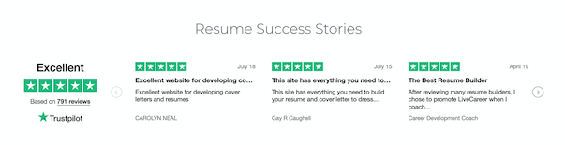

Blade 10:
Statistics and Facts About [Category] Jobs

- THIS SECTION MUST BE UNIQUELY WRITTEN FOR EVERY CATEGORY PAGE. Do not copy the flow of the pilot pages for this blade.
- Please identify the most compelling statistics about the category. Use data that is specific to the category, not to job seekers as a whole.
- Be sure to use reliable sources, including .gov, .edu, and .org websites. Avoid using sources whose content is behind a pay wall. .
- For each bit of information, add a line that says “Source: Bureau of Labor Statistics” (or wherever) and a link to where you found it so that we can fact check as we edit.
- If the data should be rendered in a chart or graph, please indicate.
- Each category will have different stats and facts that are useful. Please provide a selection of 8-10 choices for us to use.
- *This section does not have a suggested word count.

Consider referring to the following sources for this information:
- Bureau of Labor Statistics
- DataUSA
- O*Net
- Salary.com
- Glassdoor
- New York Times, Wall Street Journal, major media outlets

Here are some examples of what you might research to complete this section:

- Median Annual Pay by Job Title
- Popular job titles
- Job outlook by job title
- Education Statistics (i.e. most common degrees/certifications/professional training for workers in this category)
- Diversity stats
- “Other [Category] Industry Facts,” which can be a catch all of interesting data and metrics.

