Proper HTML code for BOLD:

Please include the HTML code within the document for the pages you are linking. It should look like this:

<a href=”URL you want to link to”>anchor text</a>

EXAMPLE:

Take a look at our <a href=”https://www.resume-now.com/templates/samples/restaurant/food-runner”>busser resume sample</a> for additional information.

Very Important: The quotation marks need to be straight quotes, rather than smart quotes.
If your Word default is set to use “curly” or “smart” quotes, sometimes you get a front quote at the end of your quote (or in this case, link) and vice versa. This causes the URL to be incorrect. Here is the way to correct the problem:

In Word, go to File, select Options and then Proofing, Click on AutoCorrect options.
Select the “AutoFormat As You Type” tab. The box next to – Replace as you type – “Straight quotes” with “smart quotes” may be checked – please uncheck this box. We only want the straight quotes, not the smart quotes.

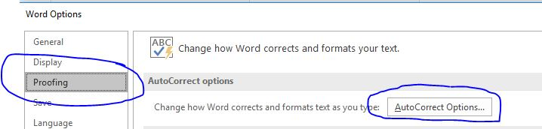
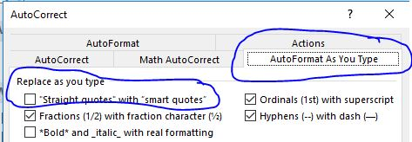

You will need to select OK at the bottom of this screen and again on the proofing screen after this one disappears, to change the default. We want to use straight quotes because they are recognized at the beginning and end of the link in the HTML code. You need to fix the default and then retype the quote marks into your code

Very Important: Do not put spaces around the anchor text. Within the code, there should not be a space either before or after the anchor text. In other words, the pattern is like this: <a href=“https://website you are linking to”>anchor text</a>. The problem is that if you have spaces within the code, the client gets double spaces when they post it. BOLD asked us to remove spaces from within the code.

EXAMPLE:

For additional information, check out our <a href=”https://www.resume-now.com/templates/samples/nursing/medical-surgery-nurse>medical surgery nurse resume sample</a>.

Linking Information

- Download the list of hyperlinks and copy and paste directly from the sheet, switching in the words you want to link to in place of “HYPERLINKED WORDS.” Or “Anchor Text”
- Keep the reader in-house for template designs and examples. Use internal links to any pages of these three websites Hloom.com/LiveCareer.com/ResumeBuilder.org when linking to template suggestions and pages. Use at least two of the High Value links that are listed.
- Also link to a minimum of 2 reputable third-party sources (Forbes, NYTimes, The Muse, well-sourced studies) in the text. Please embed the links according to html format (<a href=”HYPERLINK”>HYPERLINKED PHRASE</a>).
- Send the reader to reputable third party sources for general resume writing tips, industry information, or recruiting advice.
- Avoid any time sensitive links. For example: Is the article referring to how the 2017 job market is booming? Since it’s now 2018, let’s avoid linking to it.
- Embed the links according to html format (see the reference document and writing sample for guidance).
- Please note: When adding a hyperlink, link to a short and concise anchor text that directly reflects or repeats the words or phrasing in the link. For example: link http://www.hloom.com/how-to-write-a-resume/to the anchor text “how to write a resume” or “resume writing tips”

Be sure to ask questions as needed

