Resume Toolkit:
Applying Online –
Applicant Tracking Systems (ATS)

Applicant Tracking Systems (ATS): What Job Seekers Need to Know

Applicant Tracking Systems (often called ATS) create challenges in conducting an online search, as there are a broad range of ATS systems. It’s reported that 95%+ of Fortune 500 companies and 50% of mid-sized organizations use ATSs.

After months of research, including interviews with both internal and external recruiters, we’ve collected
recommended best practices.

Although there are many newer, intelligent ATSs on the market, they’re expensive and not many organizations invest in their HR systems. We also learned that a large number of ATS systems are ‘home grown’ with their own set of requirements. The challenge is that without insider information, there is no way to know what ATS system or software version an organization is using, so there’s not a good way to know how to best navigate past them.

The bottom-line is you need to have 2 versions of your resume.
1. Microsoft Word = “HUMAN CONSUMPTION” (i.e. visually appealing for the human eye)
2. TEXT = “ATS CONSUMPTION” (longer than 2-pages; tailored to add more relevant key words). **

*PLEASE NOTE:
USE THE TEXT VERSION ONLY WHEN UPLOADING TO ANY SITE.

Even if the site says you can upload a WORD or PDF version, we recommend you upload or copy / paste the TEXT version.

It is the best way to control that the document / content is opened and read by the user is in as user- friendly a version as possible.

The TEXT Resume created by Right Management will be an exact replica of your WORD resume, per the information that follows, you’ll need to customize or tailor that document.

What We Know for Certain

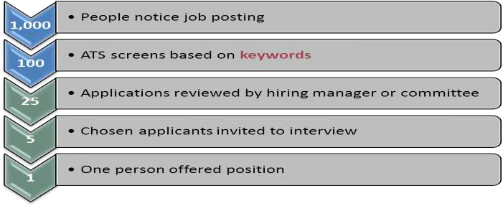
• The data are dismal (Talent Function Group, LLC)

Average # of applicants to online posting; 1st resume received
200-seconds after job lead is posted online.

Translation:
75% of resumes are
SCREENED OUT before they’re
even in the pool.

Success rate of applying online in this research?
Approximately 1%

• Many studies support the data presented in the illustration above: the success rate of applying online is under
10% (with some reported results as low as 1% or 2%). That means that less than 10% of online applicants successfully landed jobs via online applications.

• As a job search strategy, although it’s a viable option, it has a very low rate of return on the investment of your time.

• Applying online is easy to do. Please set your expectations low. The low success rate of online searches is another reason to redirect your efforts to networking.
• Networking continues to be the most effective method of finding a good fit role. Please see www.RightEverywhere.com JOB SEARCH category - SEARCH STRATEGY & NETWORKING for more.

• ATS systems search for KEY WORDS. ATS systems work like Google does; they don’t search synonyms.

• For instance, if you’re a project manager, using the key word “Deliverable” will be critical. If you’ve used the word “Outcome” instead and then listed those outcomes as “documents, plans, computer systems, etc.”

• An ATS won’t recognize that your experience includes “deliverables” because it doesn’t acknowledge the
synonym or definition of a deliverable.

• Start your experience by listing the company name first, followed by your job title, then dates.

When It Comes to Formatting a TEXT Resume,
Don’t Use:

Tables or graphs or graphics in the resume when you’re applying online. If an ATS encounters a table, it reads
up to down, not right to left. Borders or shading.
Special Characters or Accents. The correct way to write the word Résumé is with 2 accents. But this is the way it will appear to an ATS: R□sum□

Avoid credentials after your name in the top line of your resume. Several reports indicated that while it’s encouraged in a Word resume, it can confuse an ATS. The same goes for special characters, including using parentheses on your name.

Be sure to use both the acronym and spelled out versions for things like Project Management Professional (PMP)
as an ATS would miss whatever doesn’t match what is in its system.

Avoid extra spaces between letters for D R A M A T I C effect -- to the ATS it won’t be ‘dramatic’ at all.

THE SOLUTION? IF YOU’RE USING A TEXT VERSION OF YOUR RESUME, THESE
CONCERNS ARE ELIMINATED.

TEXT Resume = ATS Consumption

Remember that your TEXT resume will be different from your WORD Resume, which is formatted for “Human
Consumption.”

It’s okay to submit a longer resume as all page headers are removed and margins are adjusted to make them compatible with online systems. (Please see the section called “Creating a Resume in Plain Text Format” in the Resume Formatting Guide for more.)

Submitting a longer (even 3 or 4 page) resume that allows you to pack in more relevant experience and keywords
which could increase your chances of being “screened in.”

To a large degree it’s a numbers matching game. In other words, customize your resume’s scope statements to
match keywords in job postings and job titles.

Use those matched key words in context such as in accomplishment oriented bullets that highlight your impact or the results of your effort.

Per the previous point, key word loading isn’t recommended as with newer ATSs, the key words are taken in context.

If a hiring authority has a resume that is in the pile because of a large block of key words, our sources indicated it would in most cases cause them to dismiss the candidate from consideration for trying to ‘scam the system.’

ATS systems are even less forgiving of mistakes than humans. Errors are unacceptable. An ATS will not recognize misspelled words. Misteaks Mistakes are bad.

FAQs Regarding Applicant Tracking Systems

I still don’t think I’m clear about what an Applicant Tracking System (ATS) really is. Can you please explain it in more detail?

Applicant Tracking Systems (ATS) apply the search engine technology principles to the hiring process. The idea is that hiring authorities can type in the qualities they’re seeking in the ideal candidate and be immediately matched. The problem is that the hiring process, finding the ideal candidate who can solve your organizational problem isn’t one that can be solved by a software algorithm.

Historically, ATS systems serve 3 primary functions: 1) to help hiring authorities manage the flood of online applicants; 2) automate the process
of screening out applicants who really aren’t at all qualified for the role; and,
3) to help companies remain in compliance with federal employment law and streamline reporting.

The challenge is that research seems to indicate there are as many ATS options out there as there are mosquitoes in a swamp.

Wait, I think I’m a little confused. Can you explain that more clearly?
A recruiter shared an experience of screening out an applicant who thought she was a trainer because of her experience training other cashiers to operate new software in a classroom
setting. However, she was applying for a position as a Training Specialist that required instructional design experience, which she lacked.

It’s not surprising if you’re feeling a little confused; it’s a complicated maze. Many employers boast that they
screen out 75% of candidates' chances of landing an interview as soon as they submit their resume.

Based on our research there are too many types of ATS systems and different versions of software being used in the marketplace to have a strategy that will bypass all of them.

Our recommendations are based on best practices to help you navigate your way through the online hiring maze and increase the probability your resume will be screened in rather than screened out.
Our best practice: When applying online, always use the TEXT version of your resume. But what about newer technologies?
It is true that there are new systems like JobVite’s software that can read and analyze any format of document. That is why we recommend when uploading in any online forum, regardless of the versions the site says it will accept, upload only the TEXT version.

Remember, this is a best practice. An exception to that might be if you have inside information about what ATS
system / software the organization is using and whether or not it can read / scan text from any format.

I’ve heard that only resumes with the section header “Work Experience” can be read by ATS systems. If that’s true, then why doesn’t Right Management use that as a section header?

Although our research found ATS systems only read “Work Experience” and wouldn’t find, scan, or include any data for your experience unless it was labeled as such. We were only able to find one source who recommended labeling it as such. In other words, ATS systems like SAP, Taleo, Bull horn, Open Hire / Monster, Brassring, Resunate, to name a few, all were able to read experience in resumes without the section header called “Work Experience.”

I heard the term ‘kick out question’ but don’t know what it means, or worse, what to do about it.

Many systems, like Taleo and Jobvite, have “KICK OUT” questions which allows the system to automatically
screen candidates.

For example, when applying online, many ATS ask candidates questions such as:
Do you have less than 5 years’ experience? Yes or No. Do you have 5 to 10 years’ experience? Yes or No.
Do you have more than 10 years’ experience? Yes or No.

If the employer is ideally seeking a candidate with 7 to 10 years’ experience, how you respond determines if you make it to the applicant pool at all. Remember, 70% of applications never make it that far.

Here’s what will happen, depending on your reply:

Do you have less than 5 years’ experience?
Yes = your application is screened through, but at a lower level of consideration than those who reply they have
between 5 and 10 years’ experience.

Do you have 5 to 10 years’ experience?
Yes = Screened in for further consideration.

Do you have more than 10 years’ experience?
Yes = Screened out or automatically removed (i.e. “kicked out” of consideration.

It’s important to note, answering dishonestly to get past the screening process can also cause you to be eliminated. This is an APPLICATION system, which means you’re certifying the information you’re submitting is truthful.

Just like with a resume, if you give false information it will either disqualify or could cause you to be terminated for cause if you receive an offer. As the headlines have highlighted, there are many documented cases of
companies terminating employees for presenting false information.

Apply Online - Other Tools

Here are some screen captures of different online tools. The first is one of many for-fee sites that will evaluate your resume against a job lead, rate it, change it, and submit it for you. As for-fee sites, we don’t advocate paying for the services as the steps we’ve outlined, including “Tips for Finding the Right Key Words” in the Resume Toolkit will get you to the same, if not better results.

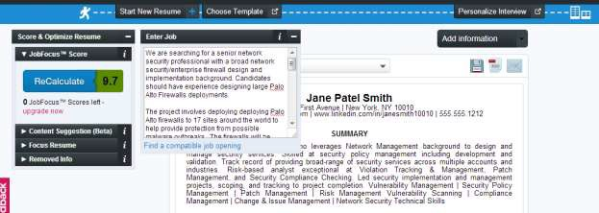
The results below are from a free trial. It may NOT reflect how other ATS systems look, but in general, they represent how they work. In this site, we uploaded a job lead that candidate Jane Smith felt was a great match. Then her resume was compared to it and ranked.

Here is the job lead content:
We are searching for a senior network security professional with a broad network security/enterprise firewall design and implementation background. Candidates should have experience designing large Palo Alto Firewalls deployments.

The project involves deploying Palo Alto firewalls to 17 sites around the world to help provide protection from possible malware outbreaks. The firewalls will be deployed in passive mode and allow all traffic to pass through, unless a malware event is detected then the firewall will block off the network segment to prevent malware from spreading.
This position offers 25%-50% remote work (from home), with the balance onsite in upstate NY. Candidates should be CONUS based. Travel expenses will be reimbursed.

Required Skills:
7 years - Network Security; 5 years - firewall deployment; 5 years - firewall design; 3 years - Palo Alto Firewall design/.deployment; Strong communication skills
Prior consulting experience; Must be able to travel; Palo Alto Certification; CCIE / CCNP
This shows how highly Jane’s resume matches with the job posting scoring a 9.7 out of 10 possible points.
Company Description
Specialized technology consulting firm offering solutions designed to meet the business challenges of our clients in both the public and private sector. We've achieved rapid success by implementing the highest level of industry quality standards into our business and service delivery model. More information can be found on our website at www.thegoalinc.com

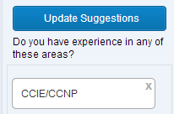
This shows how, point by point, Jane’s resume matches up. She accomplished this by using the “Tips for Finding the Right Keywords” in the Resume Toolkit.

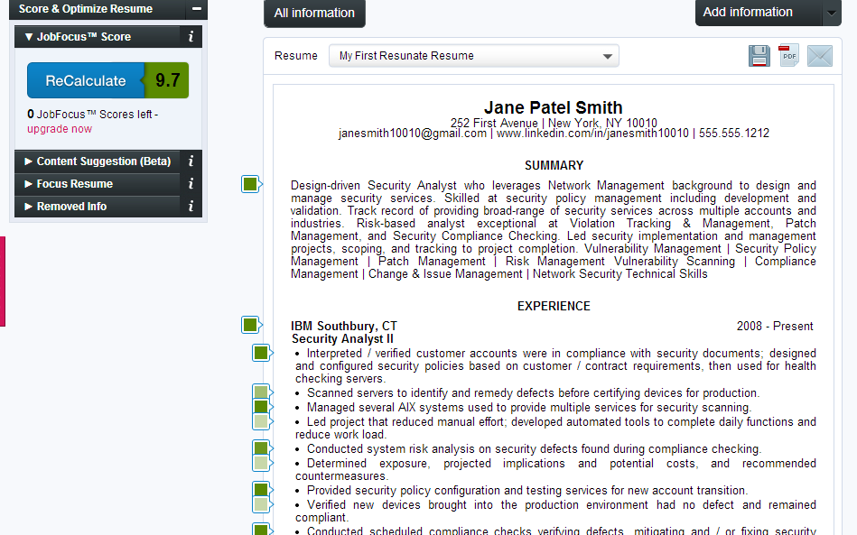
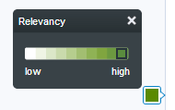
Tip: Pay attention to the details.

This site offers UPDATE SUGGESTIONS asking if she has any experience with
CCIE/CCNP.

Jane has CCNP Certification / Experience, but because the job lead is using CCIE/CCNP without spaces around the slashes, the system can’t read the CCNP on her resume.

